TÜRKİYE PUBLIC AND MUNICIPAL RENEWABLE ENERGY PROJECT

SARIKAYA MUNICIPALITY
1,962 KWP/1,600 KWE SOLAR POWER PLANT PROJECT

STAKEHOLDER ENGAGEMENT PLAN

OCTOBER 2025

TABLE OF CONTENTS
TABLE OF CONTENTS i
LIST OF TABLES ii
LIST OF FIGURES iii
LIST OF ABBREVIATIONS iv
EXECUTIVE SUMMARY 5
1 INTRODUCTION/PROJECT DESCRIPTION 6
1.1 Objectives of the sub-project 6
1.2 Components of the sub-project 6
1.3 Sub-project Location 7
1.4 Area of Influence 7
2 OBJECTIVE/ DESCRIPTION OF SEP 9
3 STAKEHOLDER IDENTIFICATION AND ANALYSIS 10
3.1 Methodology 10
3.2 Project Affected Parties 10
3.3 Other Interested Parties 11
3.4 Disadvantaged/ vulnerable individuals or groups 11
4 STAKEHOLDER ENGAGEMENT PROGRAM 16
4.1 Summary of stakeholder engagement done during project preparation 16
4.2 Commitment of Municipality Regarding Agricultural Lands 16
4.3 Summary of project stakeholder needs and methods, tools, and techniques for stakeholder engagement 16
4.4 Stakeholder engagement plan 17
4.5 Other methods for stakeholder engagement: 18
4.6 Information Disclosure 21
4.7 Proposed Strategy to Incorporate the Views of Vulnerable Groups 21
5 RESOURCES AND RESPONSIBILITIES FOR IMPLEMENTING STAKEHOLDER ENGAGEMENT ACTIVITIES 22
5.1 Project Implementation Unit (PIU) 22
5.2 Resources 22
5.3 Management functions and responsibilities 22
6 GRIEVANCE MECHANISM 24
6.1 Grievance Mechanism at National Level 24
6.2 Sub-project Level Grievance Mechanism 25
6.3 Sensitive and Confidential Grievances 27
6.4 Grievance Mechanism for Workers 27
6.5 Grievance Mechanism Flow Chart 28
7 MONITORING AND REPORTING 30
7.1 Summary of how SEP implementation will be monitored and reported 30
7.2 Reporting back to stakeholder groups 30
8 ANNEXES 32
Annex-A 32
Annex-B 34
Annex-C 35
Annex-D 36
Annex-E 37
Annex-F 39
Annex-G 47
Annex-H 48

LIST OF TABLES
Table 1. Location of Sub-project 8
Table 2. Kayapınar Neighborhood vulnerable and disadvantage groups 13
Table 3. Influence/Interest Table for stakeholder prioritization 13
Table 4. Stakeholder Engagement Plan 20
Table 6. Roles and Responsibilities 23
Table 7. Grievance Mechanism Flow Chart 29

LIST OF FIGURES
Figure 1. Location of Sub-project 8
Figure 2. Sub-project Area of Influence 9
Figure 3. Sarıkaya Municipality Website 27

LIST OF ABBREVIATIONS
AoI | Area of influence
CIMER | Presidency’s Communication Centre
DC | Distributing center
EIA | Environmental Impact Assessment
ESMP  ESMS | Environmental and Social Management Plan  Environmental and Social Management System
ESS  GBV | Environmental and Social Standard  Gender Based Violence
ETL | Energy Transmission
GM | Grievance Mechanism
GMCP | Grievance Mechanism Contact Personnel
IFC | International Finance Corporation
IFI | International Financial Institutions
ILBANK | Iller Bankası A.Ş.
LMP | Labor Management Procedure
MoEUCC | Ministry of Environment, Urbanization and Climate Change
NGO | Non-Governmental Organizations
OHS  OIP | Occupational Health and Safety  Other Interested Parties
PAP | Project Affected People
PIU | Project Implementation Unit
PUMREP | The Turkish Public and Municipal Renewable Energy Project
RE | Renewable Energy
SEA/SH | Sexual Exploitation and Abuse/Sexual Harassment
SEP  TurkStat | Stakeholder Engagement Plan  Turkish Statistical Institute
WB  YIMER | World Bank  Foreigners Communication Centre

EXECUTIVE SUMMARY
The Türkiye Public and Municipal Renewable Energy Project (PUMREP) aims to support the Government of Türkiye in expanding the use of renewable energy in the public sector, focusing on central government buildings and municipalities.The Project aims to support developing cities identifying, preparing, financing investments that enable metropolitan municipalities to plan and invest in a sustainable future while enhancing their urban planning capacities. . PUMREP is financed by World Bank (WB) to support the development of RE technologies in municipalities. ILBANK acts as a financial intermediary (FI) in this project. Sarıkaya Municipality (hereinafter referred to as the “Sub-borrower”) is the owner of this sub-project, which entails the installation of a ground-mounted Solar Power Plant with an installed capacity of 1,962 kWp / 1,600 kWe under PUMREP.
ILBANK has established an Environmental and Social Management System (ESMS) that entered into force on December 24, 2023. The ESMS aims to systematically identify, assess, manage, monitor and report environmental and social (E&S) risks and impacts of projects and sub-projects financed by International Financial Institutions (IFIs). This process should be implemented continuously throughout the loan period in line with the requirements of national legislation, international agreements and conventions ratified by Türkiye, and the E&S standards of the lending IFIs (World Bank for PUMREP). As a critical element of the ESMS, ILBANK has adopted and published an E&S Policy that applies to all ILBANK projects and sub-projects financed through IFIs.
The sub-project is classified as Moderate Risk Category in accordance with ILBANK ESMS. One of the tasks within the scope of the project is to prepare a Stakeholder Engagement Plan (SEP) in accordance with ILBANK ESMS, WBG ESF and national legislation in force in Türkiye.
The sub-project will be implemented in lot 22 of block 241, Kayapınar Neighborhood, Sarıkaya district, Yozgat province. The overall project area covers 24.13 hectares, of which 2.24 hectares will be utilized for the Solar Power Plant installation. The ownership of the sub-project site belongs to the General Directorate of National Real Estate and its pre-allocation was made to Sarıkaya Municipality on 21.10.2021.
Therefore, this Stakeholder Engagement Plan (SEP) has been prepared to identify all stakeholders, inform them about the sub-project and its potential environmental and social risks and impacts and their interest in the sub-project, and define the procedures and principles to establish effective communication with stakeholders and increase participation. This Plan aims to establish long-term relationships based on mutual trust and transparency between the sub-project and local communities. In addition, it is aimed to reduce the negative impacts that may arise from the sub-project and increase the positive impacts. With the implementation of this SEP, stakeholders will be able to access information about the sub-project, its investments, installation works and operational activities in a timely manner.
This plan includes the legal framework, the process of identifying stakeholders, and the description of the stakeholder engagement program (including the purpose and timing, the proposed strategy for information sharing, the proposed strategy for consultation, future engagement activities, the grievance mechanism covering the receipt and closure of internal and external grievances, the necessary measures to be taken and the management of grievances). In addition, specific engagement and information activities targeting vulnerable groups/individuals identified within the scope of the SEP have been defined. Based on the information obtained from the mukhtars during the consultations, it was determined that there are disadvantaged/vulnerable individuals/groups in sub-project Area of Influence (AoI) such as households living on the assistance of donors or the state, unemployed individuals, individuals migrating from the village seasonally to earn a living, households with physically disabled members, female-headed households and individuals over the age of 70 living alone. Programs have been defined for the identified disadvantaged/vulnerable groups/individuals to facilitate their participation in the consultations.
The sub-project AoI consists of environmental and social aspects including: the sub-project site, surrounding residential areas sub-project access roads and Energy Transmission Line (ETL) routes. Environmental and social impacts caused by the sub-project have been taken into consideration to determine the AoI from the sub-project area. The satellite image of the nearest settlement and its distances to the sub-project area are given in Figure 1 below. As can be seen from the figure, the nearest settlement to the sub-project area is Kayapınar Neighborhood, which is 200 m away.
The field studies aimed to obtain information about the current socio-economic structure of the neighborhood, while also determining the level of knowledge, opinions and concerns about the sub-project. Finally, at the end of this SEP, a Grievance Monitoring Table was presented that suggested the monitoring activities to be carried out to evaluate the performance and effectiveness of the sub-project.

INTRODUCTION/PROJECT DESCRIPTION

Objectives of the sub-project
The purpose of this SEP is to provide Project Affected Persons (PAPs), internal stakeholders (direct and contracted employees of the sub-project) and other relevant stakeholders with relevant, timely and accessible information so that they have the opportunity to express their views and concerns about the sub-project and potential E&S impacts.
The stakeholder engagement process under the SEP is designed to help:
• Identify and engage all potentially affected and interested stakeholders,
• Develop a good understanding of the sub-project among those who will be affected,
• Identify issues that may pose risks to the sub-project or its stakeholders early in the sub-project cycle,
• Ensure that mitigation measures are appropriate (i.e., effective and efficient),
• Establish a long-term communication system between the sub-project and communities that benefits all parties.
The SEP’s specific purpose is to;
• Define a consultation approach for stakeholders regarding the construction and operation phases of the sub-project, establish and maintain constructive relationships with the local community and other relevant stakeholders necessary for the successful management of the sub-project’s E&S impacts,
• Determine resources and responsibilities for the implementation and monitoring of the consultation program,
• Establish a grievance mechanism (GM) for external stakeholders, including a process for addressing views and concerns,
• Provide an effective grievance mechanism for internal sub-project stakeholders (direct and contract workers) to raise workplace concerns.
This SEP will guide Sarıkaya Municipality to implement structured stakeholder consultation and participation in all phases of sub-project implementation in accordance with applicable national and international regulations and WB requirements on stakeholder participation, particularly the World Bank’s ESF and ILBANK ESMS.

Components of the sub-project
Solar Power Plant (SPP)
SPP facilities will be established as solar power plants within the scope of sub-project activities.
Energy Transmission Line (ETL)
An approximately 3.5 km long overhead Energy Transmission Line (ETL) will be constructed within the scope of the sub-project. The ETL route will follow the existing cadastral road, and no new access corridor or land acquisition will be required.
Access Road
The existing stabilized road will be used as the sub-project access road within the scope of the sub-project. A new road will not be constructed.
Accommodation
The accommodation needs of the personnel who will work during the sub-project construction phase are the responsibility of the contractor company and accommodation will be provided in the Sarıkaya city center. However, a container that the personnel will use during the day will be positioned within the sub-project site. This area will be removed upon completion of the construction phase.
Waste Temporary Storage Area
Panels that become idle during the construction and operation phases will be collected in this area and delivered to the Licensed company.
Security Booth
Securities and security booths will be provided to ensure the security of the facility during construction and operation.

Sub-project Location
The sub-project activity subject is related to the establishment and operation of "Sarıkaya Municipality Solar Power Plant 1,962 kWp/1,600 kWe on lot 22 of block 241 within the borders of Kayapınar Neighborhood, Sarıkaya District, Yozgat Province. The location coordinates of the parcels in question are given in Annex-A. There is no agricultural or animal husbandry activity area or commercial enterprise on the land. It has not been used as a commercial enterprise by the municipality or 3rd parties before. Agricultural lands are located in the vicinity of the SPP site; sub project activities have been planned in a manner that will not affect these areas.
Table 1. Location of Sub-project
Province | Distirct | Neighborhood | Block | Lot
Yozgat | Sarıkaya | Kayapınar | 241 | 22

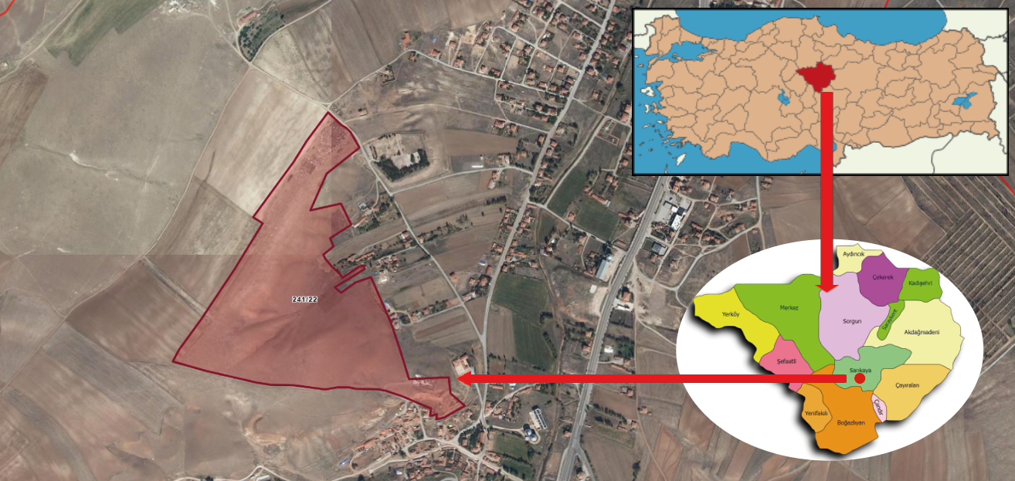
Figure 1. Location of Sub-project

Within the scope of the sub-project, a 3.5 km Energy Transmission Line (ETL) will be constructed. The entire ETL route passes through the cadastral road.
There is currently a cadastral road to access the site. Therefore, there is no need for land acquisition for the road.

Area of Influence
According to the WB ESSs, “where the project includes specifically identified physical elements, issues and facilities likely to generate impacts, environmental and social risks and impacts will be defined as the sub project area of influence (AoI).” Thus, the IA of the subproject consists of urban or rural areas likely to be affected by the sub project, its activities and the facilities directly owned, operated, or managed (including by contractors/subcontractors).
The AoI of the sub-project covers the following environmental and social aspects: the sub project site, the energy transmission line, and the access roads. To determine the AoI, a buffer zone of approximately 300 meters was considered around the site. Within this distance, the nearest residential areas were identified at approximately 200 meters from the sub project site.
The closest sensitive receptors are a park located about 50 meters away and a school about 100 meters away, both within Kayapınar Neighborhood. Due to their proximity, these receptors may be temporarily affected by construction-related dust, noise, and traffic. Furthermore, the agricultural lands directly adjacent to the sub project site were also evaluated within the AoI, considering potential impacts such as dust emissions and traffic risks.
The AoI of the sub-project is presented in Figure 2. Although the limit values are not exceeded within the scope of national legislation, it is anticipated that the limits specified in the WBG General EHS Guidelines may be exceeded. The modeling studies conducted are based on the assumption that all equipment is operating simultaneously, and lower levels of environmental noise are expected to occur under real conditions.
In case of any complaint, measurements will be made regarding construction-related environmental noise; in case the limit values are exceeded, preventive measures such as the installation of noise barriers and the regulation of working hours will be implemented.
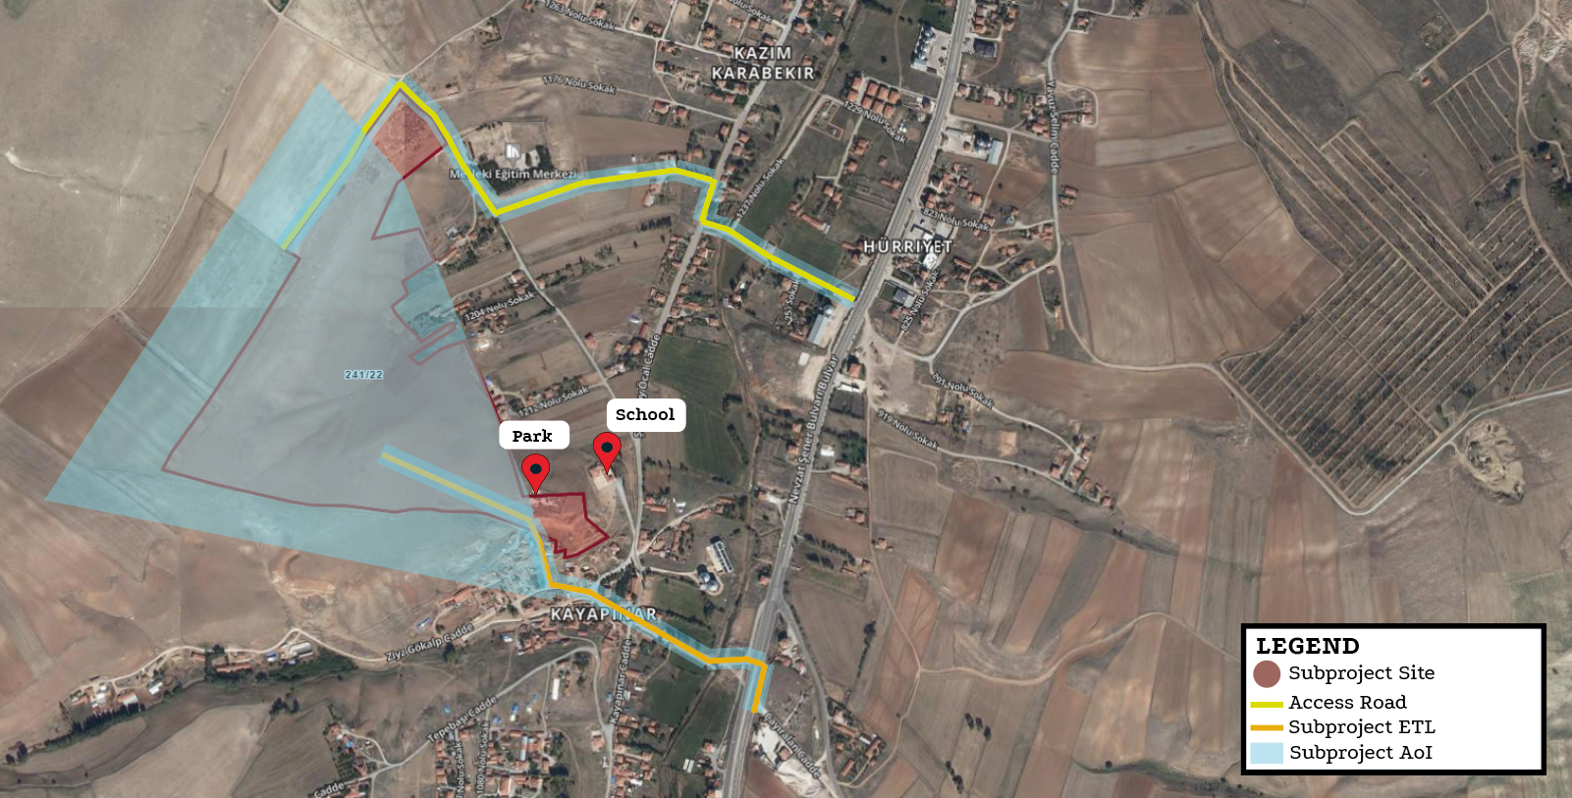
Figure 2. Sub-project Area of Influence

OBJECTIVE/ DESCRIPTION OF SEP
The overall objective of this Stakeholder Engagement Plan (SEP) is to ensure that Sarıkaya Municipality effectively identifies, engages, and maintains constructive relationships with all relevant stakeholders, particularly project-affected persons, throughout all phases of the sub-project. The SEP defines a systematic approach for stakeholder engagement, including public information disclosure, consultation, and feedback mechanisms, and specifically emphasizes methods to reach vulnerable and disadvantaged groups who may be at risk of exclusion from project benefits.
The SEP serves as a key tool in managing the environmental and social impacts of the sub-project by increasing awareness, understanding stakeholder concerns, and ensuring that their views are incorporated into project design, planning, and environmental and social performance. It promotes meaningful, inclusive, and culturally appropriate participation, providing stakeholders with timely, understandable, and accessible information, and enabling them to raise concerns or complaints, which the Municipality will respond to and manage effectively.
By creating a transparent, respectful, and fair engagement environment, the SEP fosters open dialogue, accommodates diverse cultural norms and participation capacities, and builds trust and collaboration between the Municipality and its stakeholders. Developed in compliance with national legal requirements and the World Bank Environmental and Social Standard 10 (ESS10), this sub-project-specific SEP is a public document that will be regularly updated to reflect ongoing stakeholder discussions and input throughout the sub-project lifecycle.

STAKEHOLDER IDENTIFICATION AND ANALYSIS
In the stakeholder identification process, the potential impacts of the sub-project are assessed, and strategies for engaging stakeholders are developed, including the frequency and methods of communication. It is especially important to focus on identifying vulnerable or disadvantaged groups who may be more severely affected by the sub-project or face challenges in participating in the engagement process. Identifying stakeholders is an ongoing activity and will be continuously reviewed and updated as needed.

Methodology
To follow best practices in stakeholder engagement, the project will apply the following principles:
- Openness and Life-cycle Approach: Public consultations will be held throughout the entire project life cycle in an open and transparent way, ensuring that there is no outside influence, manipulation, or intimidation.
- Informed Participation and Feedback: Relevant information will be shared with all stakeholders in an accessible format. There will be opportunities for stakeholders to provide feedback, and their comments and concerns will be carefully analyzed and addressed.
- Inclusiveness and Sensitivity: The stakeholder identification process will focus on building strong, effective relationships and ensuring that all stakeholders are included in the consultation process. Everyone will have equal access to information. Engagement methods will be chosen based on the needs of the stakeholders, with particular attention to vulnerable groups such as women, the elderly, people with disabilities, displaced persons, migrant workers, and communities. Cultural sensitivities will also be carefully considered to ensure the participation of diverse ethnic groups.
- Flexibility: If social distancing, cultural context (for example, particular gender dynamics), or governance factors (for example, high risk of retaliation) inhibits traditional forms of face-to-face engagement, the methodology should adapt to other forms of engagement, including various forms of internet- or phone-based communication.
For Sarıkaya Municipality SPP project, the following stakeholders have been identified and analyzed per sub-project component. These stakeholders include affected parties, other interested parties and disadvantaged/vulnerable individuals or groups
.

Project Affected Parties
Project Affected Parties (PAPs) are the persons, groups, and other entities within the Project’s AoI that are directly influenced (actually or potentially) by the Project and/or have been identified as most susceptible to change associated with the Project, and who need to be closely engaged in identifying impacts and their significance, as well as in decision-making on mitigation and management measures. In this project, specifically, the following individuals and groups fall within this category:
• Residents of Kayapınar neighborhoods who are located within the AoI will experience direct impacts from construction activities, particularly due to increased levels of noise, dust, and temporary disruptions such as road closures or restricted access.
• Agricultural land users in the AoI may be temporarily affected by dust emissions, noise, and limited access to their fields.
• Construction workers (direct and contracted): Workers engaged in the construction activities are also considered PAPs, as they may be exposed to occupational health and safety (OHS) risks, working conditions, and employment-related issues during the implementation of the sub-project.

.

Other Interested Parties
The projects’ stakeholders also include individuals/groups/entities that may not experience direct impacts from the Project but who consider or perceive their interests as being affected by the project and/or who could affect the project and the process of its implementation in some way, including:

Ministry of Environment, Urbanization and Climate Change (MoEUCC)
- General Directorate of EIA, Permit and Inspection
- General Directorate of Environmental Management
- General Directorate of Infrastructure and Urban Transformation
- General Directorate of Spatial Planning
- General Directorate of Protection of Natural Assets
Ministry of Labor and Social Security
- General Directorate of Labor
- General Directorate of Occupational Health and Safety
Yozgat Governorship
- Social Security Institution Provincial Directorate
- Provincial Directorate of Environment, Urbanization and Climate Change
Yozgat Provincial Directorate of Civil Society Relations
Centre District Governorship
Yozgat Environment, City and Culture Presidency
- Kayseri Regional Directorate of ILBANK
Civil society organizations and community groups: Organizations or associations that may have an interest in environmental, social, or technical aspects of the sub-project.
- Yaşanabilir Çevre Association
- Yozgat Cemre Association
- ORAL Development Association
National and local media: Media outlets that may provide coverage of the project and inform the public.
- National Press
  - Anadolu Agency
  - Demirören News Agency
- Local Press
- Hakimiyet Newspaper
Universities and research institutions: Academic institutions that may have an interest in research, monitoring, or technical aspects of the sub-project.
- Bozok University
These OIPs are engaged to ensure transparency, foster constructive dialogue, and strengthen the sub-project’s social acceptability and sustainability.

Disadvantaged/ vulnerable individuals or groups
Disadvantaged/Vulnerable individuals or groups are persons who may be disproportionately impacted or further disadvantaged by the project(s) compared with any other groups due to their vulnerable status, and that may require special engagement efforts to ensure their equal representation in the consultation and decision-making process associated with the project. These groups have been identified through field studies and consultations with local representatives, and their participation will be supported through tailored communication and engagement methods
Elderly individuals living alone may experience mobility limitations and have limited access to social support networks, making them more susceptible to the impacts of project activities. Persons with physical or mental disabilities may require assistance or adapted communication materials to access project-related information and participate meaningfully. Female-headed households often face time constraints, heavy domestic responsibilities, and, in some cases, cultural barriers that limit their ability to engage in community consultations and project-related opportunities.
Individuals who rely on state or private assistance are considered vulnerable due to their economic dependence and restricted access to information and resources. This may limit their ability to benefit from services, opportunities, or information provided under the project. Similarly, unemployed individuals may experience financial hardship and be less able to engage with the project or benefit from temporary employment opportunities or social services offered during implementation, making them a key vulnerable group.
According to information obtained from the mukhtar of Kayapınar Neighborhood details on these vulnerable and disadvantaged groups are provided in Table 2.
Table 2. Kayapınar Neighborhood vulnerable and disadvantage groups
Vulnerable and Disadvantage Groups | Number of People
Over 70 years of age and living alone | 1
Mentally disable | 3
Physically disable | 1
Surviving on social assistance from the state, associations or individuals | 40
Female-headed household | 5
Unemployed individuals actively seeking work but unable to find employment | 10
Total Vulnerable and Disadvantage Groups | 60
Source: Mukhtar and Local People Meetings, 2025.
To enhance the participation of these groups, informational materials will be prepared using visual aids and written in clear, simple language. If deemed necessary, home visits and small group meetings will be organized. Printed materials will be designed in a clear and easy-to-read format. To ensure broad public participation, meetings will be held in accessible venues that do not pose any barriers for persons with disabilities. Meeting times will be scheduled to accommodate the availability of women and working individuals. Transparent and consistent communication will be maintained throughout the process to ensure that participants do not experience a loss of trust.
How each stakeholder group will be affected by the sub-project and their interest in the project; the area of influence and the nature and quantity of the impacts that may arise were determined. The stakeholders determined as a result of the interviews with the mukhtar of Kayapınar neighborhood and local people, interviews with non-governmental organizations, public institutions and organizations and the information obtained from Sarıkaya Municipality are given in Table 3.
Table 3. Influence/Interest Table for stakeholder prioritization
Stakeholder Group |  | Cause of Impact/Risk | Level of Interest | Level of Influence
Project Affected Parties | - Communities likely to be affected by the construction works in the scope of component (Kayapınar Neighborhood)  - Workers to be employed for the construction activities | Heavy vehicles used during the construction process may create temporary traffic congestion in the neighborhood, but other than that, the sub-project is not expected to have any permanent socio-economic or environmental impact on the neighborhood | High | Medium
Project Affected Parties | - Workers (including supply chain) to be employed for the sub-project activities | Potential risks related to working conditions, etc. | High | High
Other Interested Parties | - Landowners of adjacent parcels with agricultural spillovers into the subproject area | For the land users cultivating neighboring parcels, the potential cause of impact or risk is associated with the presence of agricultural spillovers extending into the sub-project area. These users may have concerns regarding possible restrictions or disruptions to their farming activities due to project fencing or construction works. However, field assessments and consultations confirmed that the natural agricultural spillovers will remain outside the fenced boundaries of the solar power plant, and agricultural activities on neighboring parcels will not be affected. Therefore, no risk of livelihood loss or economic displacement is anticipated. | Medium | Low
Other Interested Parties | NGOs:  - Yaşanabilir Çevre Association  - Yozgat Cemre Association  - ORAL Development Association | NGOs can submit suggestions on the environmental and social impacts of the sub-project depending on their field of activity; therefore, it is important to effectively manage the information and transparency processes. | Medium | Low
Other Interested Parties | Public Institutions  Ministry of Environment, Urbanization and Climate Change (MoEUCC)  - General Directorate of EIA, Permit and Inspection  - General Directorate of Environmental Management  - General Directorate of Infrastructure and Urban Transformation  - General Directorate of Spatial Planning  - General Directorate of Protection of Natural Assets  Ministry of Labor and Social Security  - General Directorate of Labor  General Directorate of Occupational Health and Safety Yozgat Governorship  - Social Security Institution Provincial Directorate  - Provincial Directorate of Environment, Urbanization and Climate Change  Yozgat Provincial Directorate of Civil Society Relations Centre District Governorship  Yozgat Environment, City and Culture Presidency  Kayseri Regional Directorate of ILBANK  - Local administration  - Yozgat Municipality  - National Press  - Anadolu Agency  - Demirören News Agency  - Local Press  - Hakimiyet Newspaper  - Bozok University | A positive impact is expected with the energy generated from the sub-project. Government agencies may be involved in the permitting process, land acquisition process or in organizing consultations with communities. | High | Low
Vulnerable individuals or groups | - People over 70 years of age;  - Female head of households  - Mentally disable  - Physically disable  - Surviving on social assistance from the state, associations or individuals  - Unemployed individuals actively seeking work but unable to find employment | - People Over 70 Years of Age may have difficulty physically attending stakeholder participation meetings or information activities.  - Unemployed individuals also have difficulties in accessing temporary employment opportunities or benefiting from social support services that can be offered within the scope of the project due to their economic fragility.  - Female Head of Households may have obstacles in terms of time and access to participating in information meetings due to family responsibilities.  - Individuals with mental disabilities may have limited access to education and employment, may not be aware of their rights, and may have difficulty living independently without support.  - Individuals with physical disabilities may have difficulty participating in sub-project activities without support. If the necessary infrastructure is not provided, they may experience education and employment difficulties.  Social assistance may prioritize economic conditions due to the lack of stability in meeting their basic needs. | High | Medium

STAKEHOLDER ENGAGEMENT PROGRAM
The main objectives of the stakeholder engagement program and the planned timetable for the various stakeholder engagement activities are to define at what stages and at what intervals these activities will be carried out throughout the life of the sub-project. Information is provided on how the public will be made aware of future opportunities to review information and provide their views, if decisions about public meetings, locations and timing of meetings have not yet been made.

Summary of stakeholder engagement done during project preparation
A field visit was carried out on 26.06.2025 in order to inform the local people about the project and to receive their opinions and suggestions in accordance, and interview was held with Kayapınar neighborhood mukhtar and Sarıkaya Municipality officials about the usage status of the sub-project site and the disadvantaged groups living in the region.
Within the scope of the interviews;
It was determined that the sub-project site was not currently used by the local people for any purpose, and that there were no refugees or child-headed people living in Kayapınar neighborhood, the closest settlement to the sub-project site.
In addition, within the scope of the Stakeholder Engagement Plan, consultation meetings were held with Kayapınar neighborhood residents and the mukhtar by CA Engineering authority A**** G***** on 26.06.2025. In order to obtain general information about the socio-economic situation of Kayapınar neighborhood and to learn about their knowledge levels about the project, the mukhtar of Kayapınar neighborhood applied a "Community Level Survey" (Annex-F).
Consultations with nearby landowners were conducted during the site visit to clarify the sub-project boundaries and address the issue of temporary agricultural spilloverst. During these discussions, landowners confirmed that the parcels do not constitute their sole source of livelihood, that they are engaged in other income-generating activities (mainly trade), and that no adverse economic impacts are anticipated. The stakeholders acknowledged the boundary limits and confirmed that no further spillovers will occur after the current harvest season. No grievances were raised during the consultation process.
The Community Level Survey Form is used to gather information on the socio-economic structure of settlements, assess their level of awareness regarding the proposed sub-project, identify their preferred communication channels for future consultation activities, and understand their environmental and social concerns. The findings help develop alternative mitigation measures tailored to these concerns within the scope of the ESMP.
Following the approval of the draft ESMP and SEP, additional Public Participation Meetings will be organized as needed within the scope of the sub-project activities. Minutes of Public Participation Meetings will be recorded and maintained as part of the sub-project documentation. Prior to such meetings, informative posters, brochures, and announcements will be prepared and displayed in areas with high pedestrian traffic or broadcast via digital screens. In addition, the meetings will be announced on the Sarıkaya Municipality’s official website, as well as through local and national newspapers, at least 10 days in advance. Public participation meetings will be organized in a manner that encourages the highest possible level of participation.
Stakeholder Consultation Meetings are held within the scope of sub-project activities. Prior to each meeting, informative posters, brochures, and announcements are prepared and displayed in locations with high pedestrian traffic or broadcast via digital screens. In addition, the meetings are announced on the Sarıkaya Municipality’s official website at least 10 days in advance. Stakeholder consultation meetings are organized in a manner that encourages the highest possible level of participation.
Within the scope of the Sarıkaya Municipality Solar Power Plant Project, a Stakeholder Consultation Meeting was held on 23.12.2025 with the participation of local residents, municipal representatives, and other relevant stakeholders. The primary objectives of the meeting were to inform stakeholders about the sub-project, provide a platform for open discussion, and collect feedback regarding potential environmental and social impacts.
Prior to the meeting, announcements were disseminated through local communication channels, including neighborhood mukhtars and municipal communication tools, to ensure broad community awareness and encourage participation. The meeting was attended by 19 local residents from Kayapınar Neighborhood. All participants were male.
During the meeting, detailed information was provided regarding the project location (neighborhood, block, and parcel), the scope of the solar power plant, its main technical components, installed capacity, estimated energy generation, and the project’s anticipated contribution to the reduction of carbon emissions.
Potential environmental and social impacts—particularly during the construction phase, such as dust, noise, and temporary increases in traffic—were discussed in detail. Participants were also informed about the mitigation measures defined in the Environmental and Social Management Plan (ESMP), as well as the grievance mechanism that will be available to stakeholders throughout all stages of the project.
During the consultation, participants raised questions regarding whether solar panels could lead to local temperature increases, whether any noise would be generated during the operation phase, how the entry of livestock into the project area would be prevented, and whether households would directly benefit from the electricity generated by the project.
Project representatives explained that solar panels do not cause a noticeable increase in ambient temperature and that operational noise levels are negligible. Regarding livestock and grazing activities, it was stated that the project site would be securely enclosed with appropriate fencing and warning signage to prevent unauthorized access and ensure both community safety and protection of animals, while existing grazing activities outside the project boundaries would not be adversely affected.
In response to questions about electricity use, it was clarified that the electricity generated by the solar power plant would be supplied to the national electricity grid in accordance with applicable legislation, and that households would not receive electricity directly from the facility. However, it was emphasized that the project would contribute indirectly to the local community by supporting renewable energy generation, reducing carbon emissions, and lowering the municipality’s energy costs, thereby strengthening municipal services.
Project representatives emphasized that all feedback and concerns raised during the meeting would be taken into consideration during project implementation.
Overall, the consultation meeting contributed to enhancing community awareness, promoting transparency, and demonstrated the municipality’s commitment to continuous and meaningful stakeholder engagement. A copy of the meeting minutes, the signed participant list, and photographic documentation are provided in Annex-I.

Commitment of Municipality Regarding Agricultural Lands
During the stakeholder consultations, the potential impacts of the sub-project on nearby cultivated areas were discussed. In order to provide assurance, Sarıkaya Municipality issued an official written commitment stating that the project will not interfere with the cultivated lands of neighboring parcels and that agricultural activities will not be adversely affected. This written commitment has been shared with the landowners and is included as an annex to this SEP (Annex-H).

Summary of project stakeholder needs and methods, tools, and techniques for stakeholder engagement
Identifying and managing stakeholder needs accurately in sub-project is critically important. Key stakeholder needs include regular updates about the sub-project, stakeholders in decision-making processes, direct or indirect benefits from the sub-project, and an effective communication mechanism. Tools such as surveys and one-on-one interviews will be effectively utilized in information-sharing and engagement processes. Additionally, regular reporting, dashboards, and online communication tools will ensure transparent updates about sub-project progress. Community meetings and feedback mechanisms will help build trust in the sub-project while providing a better understanding of stakeholders' needs and expectations. Through these methods, stakeholder engagement in sub-projects will be strengthened, making the projects more inclusive, sustainable, and effectively managed.
Stakeholders have been identified within the scope of the sub-project and consultations or key information meetings have been held with these stakeholders. Stakeholders identified in the region have been informed about the location, components and content of the sub-project.
This plan shows the nature and level of stakeholder interest in the project, how the participation will be conducted, the frequency of participation and the responsible unit of Sarıkaya Municipality, and the following matrix provides a tabular version of this program (See Table 4).
The responsible party/person should be determined by the representatives of Sarıkaya Municipality. The SEP will be implemented at the sub-project level. Registration forms and full meeting minutes of those who participated in the consultations will be recorded as an annex to the SEP, but personal information will not be made publicly available. When the SEP is disclosed, relevant data containing personal data will be blurred, taking into account the Personal Data Protection Law.
All supporting documentation for stakeholder activities (newspaper notices, attendee list, full meeting minutes (as an annex), the presentation, sample brochure) will be included in the SEP.
The Stakeholder Consultation Meeting (SCM) to be held within the scope of the sub-project will be held face to face. A shuttle service will be provided to ensure the participation of vulnerable groups, and online participation will be provided for groups that still cannot participate.
In the participation of women in consultation activities, meetings will be held under conditions that take cultural sensitivities into account. In addition, meetings will be planned at appropriate times (e.g. evenings or weekends) depending on their age and workload.

Stakeholder engagement plan
A stakeholder engagement plan is an important tool for a project or organization to communicate effectively with its stakeholders, manage the project successfully and achieve its objectives.
The first Stakeholder Consultation Meeting (SCM) of the sub-project will be held following the approved by İLBANK draft ESMP report in a selected venue in Sarıkaya which will have sufficient capacity and facilities, thus facilitating comfortable and efficient communication. Above mentioned PAPs and OIPs will be invited to the SCM.
Prior to the SCMs, announcements will be published in local and national newspapers, and on Sarıkaya Municipality's official website. Sub project information brochures will be distributed 10 days prior to the meeting to the participants before the meetings begin and sub-project maps will be made available in the brochures and in public places like village tea houses, mukhtars’ offices. Not only will announcements be made through official means, but also the involvement of the local people will be encouraged by contacting the mukhtars prior to the meeting in order to encourage them about the meeting and the subproject.
In addition to official announcements, local participation will be encouraged by the Social Expert of PIU through direct engagement with community leaders. To ensure the inclusion of vulnerable groups such as seasonal migrants and Syrian refugees, local leaders will be consulted in the field. Neighborhood visits will be carried out according to the construction activities calendar. Mukhtar(s) and local people will be informed in detail about the project and the grievance mechanism within the sub-project through consultation meetings.
Consultation meetings will begin with an introduction and an explanation of the purpose and scope of the meeting, and followed by a final discussion session where questions, concerns and suggestions were taken after the presentations made by PIU.
The main topics which will be covered in the presentations are as follows:
•Aim and the coverage of the sub-project.
• Who are the Project Main Executive Body, Project Beneficiary and Executing Organization and Project Sponsors?
•What are the expected benefits of the Project?
•What are Environmental and Social Negative Impacts? An overview of the anticipated environmental and social negative impacts of the sub project and the measures suggested to mitigate these (participants will be invited to discuss any additional negative impacts they might foresee and offer views on whether the planned measures are sufficient or suggest alternative or additional measures)
•Grievance mechanism
•Discussion (Questions and Answers) Session
Consultation meetings will be conducted in a participative manner. The locals will be encouraged to express their own ideas about the subproject and their opinion in order to minimize the negative social impacts of the project. A brochure will be prepared covering those topics and will be distributed during the consultation meetings and will be distributed in public places. The brochure will include the communication information of the required contact phone numbers and email addresses and during the consultation meetings, the locals will be encouraged to contact sub project social experts.

Other methods for stakeholder engagement:
Regular site visits aiming face-to-face meetings will be implemented by the contractor company social expert in order to:
Carry out grievance processes,
Further disclosure of the project,
Identifying any population change which may bring existence of any disadvantaged/vulnerable person.

Site visits can also be done with the demand of a local, while the visit of the locals to the sub project management offices can also be defined as a tool for stakeholder engagement activity.
Phone calls or text messages can be preferred according to certain circumstances but preferable meeting technique is to conduct the meetings face-to-face. The proposed Stakeholder Engagement Schedule is provided in Table 4.

Table 4. Stakeholder Engagement Plan
Project Stage | Estimated Date/Time Period | Topic of Consultation/ Message | Method Used | Target Stakeholders | Responsibilities
Pre-construction | At least 10 days before the construction phase begins | Information Statement  - General information about the purpose, stages, Project and E&S impacts/risks  - Purpose, start date, duration and nature of land preparation, construction and operation activities  - Implementation of mitigation measures related to relevant social and environmental impacts/risks  - Grievance Mechanism  - Information (ESMP and SEP) on Sarıkaya Municipality website for review  - E&S documents (ESMP and SEP) | Public Consultation Meeting  Sarıkaya Municipality website  Social Media  Notice Boards  Booklets etc.  Posters to be hung in work areas etc. | Resident of Sarıkaya neighborhood,  Local communities,  Local government,  Local business | SupervisionConsultant,  Sarıkaya Municipality,  Contractor  E&S Consultant,  Construction Company,  Sub-project Contractors
Pre-construction | At least 10 days before the construction phase begins | Employment and Supply Strategies  - Hiring employees  - Staff training  - Purchasing materials and services  - Grievance Mechanism | Public Consultation Meeting  Sarıkaya Municipality website  Social Media  Notice Boards  Booklets etc.  Posters to be hung in work areas etc. | Local businesses,  All local communities
Construction | Once a month | Information Statement  - Monitoring targets and activities to be carried out  - Monitoring targets and activities and regular reporting of monitoring results to stakeholders | Public Consultation Meeting  Sarıkaya Municipality website  Social Media  Notice Boards  Booklets etc.  Posters to be hung in work areas etc. | Resident of Kayapınar Neighborhood,  Local communities,  Local government, | SupervisionConsultant,  Sarıkaya Municipality, Contractor E&S Consultant,  Construction Company,  Sub-project Contractors
Construction | Once a month | Traffic and Transport Management  - Road safety awareness, including safe passage through bypasses and connecting roads  - Types, number and frequency of vehicles to be used during construction  - Collaboration with local communities and responsible authorities to improve signage, visibility and overall road safety, especially along roads near schools or other places where children are present,  - Planning and timing of construction activities on roads,  - Regarding training on traffic and pedestrian safety cooperating with local communities (e.g. school education campaigns)  - Traffic measures and sub-project road use sharing with association president  - Grievance Mechanism | Face-to-face meetings,  Depending on the demands of the stakeholder group,  Posters to be hung in work areas, etc.,  Sarıkaya Municipality website | All local communities
Operation  In case of demand or significant change | To be determined based on project requirements and stakeholder engagement needs | Information Statement  - Monitoring targets and activities to be carried out  - Monitoring targets and activities and regular reporting of monitoring results to stakeholders  - General information about the sub-project, environmental and social impacts, mitigation measures, monitoring activities of the sub-project  Grievance Mechanism | Face to face meetings | Resident of Kayapınar Neighborhood | Sarıkaya Municipality

Sarıkaya Municipality will make sub-project E&S documents available on its website in both Turkish and English . These documents will also be accessible at Sarıkaya Municipality office. In addition, sub-project posters and information on the grievance mechanism will be displayed at local points, including Kayapınar Neighborhood Mukhtar's Office. Stakeholder consultations will be conducted to review draft E&S documents before they are finalized and disclosed. This process will ensure that stakeholders' views and concerns are valued and integrated, promoting a more effective and inclusive outcome.

Information Disclosure
For each of the targeted stakeholder group, different disclosure methods and means will be used in order to increase the disclosure level. Especially for the stakeholder consultation meetings, the meeting venue, time and date will be arranged, and that information will be announced to the public at least 10 days before the event, making sure that all community members are informed about the event. The announcement will be made through public notices in both at least one local and one national newspapers, at Sarıkaya Municipality’ s website and information postings at the offices of the mukhtars of the sub project neighborhoods.
The PIU will use its institutional website and official social media accounts to share key project information with stakeholders and the public. In addition, printed leaflets and visual materials will be distributed. To improve understanding, simplified brochures summarizing environmental and social documents will be prepared. These materials will use clear language and visuals, considering the needs of groups with limited literacy or digital access.
Information will be disclosed in a culturally appropriate manner and in formats accessible to all stakeholder groups, including persons with disabilities, elderly individuals, and women.

Proposed Strategy to Incorporate the Views of Vulnerable Groups
During the construction phase, Sarıkaya Municipality social expert might first announce the time and place of the construction works to the locals. During the information activity, the social expert will also investigate the above mentioned disadvantaged individuals and assess required mitigation activities in order to eliminate the negative impacts of the construction works. It has to be kept in mind that requiring information from secondary information sources like mukhtars or teachers might not be enough as the persons with disadvantages may not be officially registered in any health care or educational institution. As a matter of fact, a detailed Public Consultation Meetings have to be conducted in order to identify them. Face-to-face meetings will be conducted with any identified disadvantaged/vulnerable person. In case of any communication irrelevancy (i.e. with individuals with mental disabilities or children) meetings will be conducted with parents or relatives.
During the planning and execution stages of the sub-project, efforts will be made to gather opinions of vulnerable or disadvantaged groups in order to guarantee that their needs are taken into account. Households with persons with disabilities, households headed by women, households headed by Syrian refugees, and households headed by seasonal agricultural laborers are examples of vulnerable or disadvantaged populations. However, this list is not exhaustive. Getting these groups involved is absolutely necessary in order to promote inclusiveness and address the challenges that are unique to them.
It is planned to interact with the mukhtars and non-governmental organizations (NGOs) that work closely with these communities in order to identify these groupings. In order to guarantee the inclusion of certain groups, interviews and home visits will be carried out for those groups.
To further ensure the inclusion of vulnerable groups—such as seasonal agricultural workers or refugees—Sarıkaya Municipality’s Project Social Expert will prioritize gathering information on these groups during field visits and consultation preparations.

RESOURCES AND RESPONSIBILITIES FOR IMPLEMENTING STAKEHOLDER ENGAGEMENT ACTIVITIES

Project Implementation Unit (PIU)
PIU will be established within Sarıkaya Municipality and will consist of Sarıkaya Municipality personnel. The GMCP is the designated personnel responsible for recording, monitoring and coordinating the resolution of grievances regarding the sub-project. The GMCP, the first point of contact for complainants, will ensure confidentiality and impartiality at all stages of the grievance (registration, monitoring, resolution, etc.). The duties and responsibilities of PIU and GMPC are explained in Table 6.
A sufficient budget will be allocated for communication and complaint resolution mechanism to be established with stakeholders. The budget is included in the project budget.

Resources
Sarıkaya Municipality is ultimately responsible for the environmental and social performance of the entire sub-project, including the performance of its own contractors and other contractors. A Project Implementation Unit (PIU) will be established to carry out operational and administrative tasks. The PIU staff will be Sarıkaya Municipality’s own staff.
The PIU will be primarily responsible for coordinating stakeholder engagement activities with the Contractors as outlined in this SEP. The collection of complaints, questions and feedback will be the direct responsibility of the PMU’s GM contact person (GMCP) and the Contractors’ E&S Specialist.
The resources to be provided by Sarıkaya Municipality are as follows:
- A project-specific area on the Sarıkaya Municipality’s official website,
- An electronic database for grievances,
- Stakeholder engagement records,
- Printed documents (guides, brochures, posters, etc.) to be used in accordance with the SEP requirements.

Management functions and responsibilities
Sarıkaya Municipality/PIU will be the main party responsible for the implementation of the SEP and coordination with contractors, implementation, monitoring and reporting. Detailed roles and responsibilities regarding the stakeholder participation of the sub-project are provided in Table 6.
Table 5. Roles and Responsibilities
Responsible Entity | Roles and Responsibilities
PIU of Sarıkaya Municipality | - Planning and implementation of the SEP;  - Leading stakeholder engagement activities in close collaboration with the ILBANK PMU;  - Management and resolution of grievances;  - Consultation on specific SEP activities;  - Announcing the important construction activities;  - Reporting on implementation of SEP activities to ILBANK PMU;  - Proper implementation of the grievance mechanism defined in the SEP, and  - Executing defined grievance mechanism in the SEP properly and informing ILBANK PMU about the overall implementation status.
GMCP | - Act as a focal point for the GM in the PIU  - Keep records and monitor sub-project-related grievances  - Manage and coordinate the resolution process of sub-project related grievances  - Review grievance records for relevant non-compliance issues or recurring issues related to stakeholder engagement and other sub-project activities  - Coordinate and monitor PIU contacts at the contractor level  - Collect sub-project related grievances from all different parties  - Inform PIU and management about the resolution process  - Prepare compiled PIU reports on the sub-project  - Monitor contractors’ grievance records and grievance resolution process and report to PIU in monthly progress reports  - Maintain communication with PIU to respond/resolve grievances
E&S Consultant | - E&S Consultant is responsible for preparing the Environmental and Social Assessment Reports, i.e. ESMP and SEP, for the approval of ILBANK,  - Providing the necessary information to the Sarıkaya Municipality,  - Taking a part in organizing the ESMP stakeholder consultation meeting to be held for all stakeholders and  - Submit final drafts of the reports as per the concerns/opinions of the stakeholders.
GMCP | - Act as a focal point for the GM in the PIU  - Keep records and monitor sub-project-related grievances  - Manage and coordinate the resolution process of sub-project related grievances  - Review grievance records for relevant non-compliance issues or recurring issues related to stakeholder engagement and other sub-project activities  - Coordinate and monitor PIU contacts at the contractor level  - Collect sub-project related grievances from all different parties  - Inform PIU and management about the resolution process  - Prepare compiled PIU reports on the sub-project  - Monitor contractors’ grievance records and grievance resolution process and report to PIU in monthly progress reports  - Maintain communication with PIU to respond/resolve grievances
Supervision Consultant | - Ensure that the sub-project complies with the methodology and other requirements specified in the E&S Documents (ESMP and SEP) during the implementation of sub-projects,  - Recording and monitoring the resolution of grievances from contractors and reporting them to Sarıkaya Municipality (PIU) in the monthly progress reports,  - Maintaining communication with PIU GM Focal Point for follow-up of grievances.
Contractor | - Recording and monitoring resolution of contractor grievances and reporting them to PIUs in monthly progress reports,  - Maintaining communication with PIU GM Focal Point to follow up on grievances,  - Organizing and conducting Stakeholder Consultation Meetings and related events for public information sharing,  - Informing ILBANK (PMU) and Sarıkaya Municipality on all matters related to their relations with stakeholders,  - Informing local communities on all environmental and social issues (e.g. noise, vibration, water quality monitoring, community health and safety, etc.)  - Developing and implementing a grievance mechanism for both the E&S performance of the project and the workforce, including subcontractors, prior to the commencement of works in accordance with Sarıkaya Municipality’s GM requirements.  - Submits monthly Environmental and Social Monitoring Reports (ESMRs) to Sarıkaya Municipality,

GRIEVANCE MECHANISM
Managing, preventing, minimizing and effectively addressing complaints is an integral part of a sound stakeholder engagement strategy. Experience shows that a significant number of complaints arise from misunderstandings and that such complaints can be prevented or reduced through proactive and consistent engagement with communities. Participation also helps to anticipate and review community concerns and prevent them from turning into complaints. Therefore, according to the WB, the following Grievance Mechanism (GM) will be implemented by Sarıkaya Municipality/PIU throughout the life of the sub-project, including pre-construction, construction and operation phases. In the GM, comments/grievances will be received in Turkish, since almost everyone in the developed GM speaks Turkish, there will be no need to use another language. The grievance channels used in applications will be published in Turkish. GM forms and consultation records will be kept in Turkish.

Grievance Mechanism at National Level
Presidential Communication Center: The Presidential Communication Center (CIMER) provides a centralized complaint system for Turkish citizens, legal entities and foreigners. The Presidential Communication Center (CIMER) will serve as an alternative and well-known channel through which Project stakeholders can directly communicate their complaints and feedback regarding the Project to government officials.
- www.cimer.gov.tr
- Call Centre (hotline): 150
- Phone number: +90 312 525 55 55
- Fax number: +90 0312 473 64 94
- Address for Official Letter/Petition: Republic of Türkiye, Directorate of Communications Kızılırmak Neighborhood. Mevlana Boulevard No:144 Çankaya/ANKARA
Mail addressed to Republic of Türkiye, Directorate of Communications
Individual applications at the community relations desks at governorates, ministries and district governorates.
Foreigners Communication Center (YIMER) will be available to Project stakeholders as an alternative and well-known channel for conveying their Project-related grievances and feedback directly to state authorities.
- www.yimer.gov.tr
- Call Centre (hotline): 157
- Phone number: +90 312 515 11 22
- Fax number: +90 0312 920 06 09
- Address for Official Letter/Petition: Republic of Türkiye, Directorate General of Immigration Management Çamlıca Neighbourhood No: 4 Yenimahalle/ANKARA
Mail addressed to Republic of Türkiye, Directorate General of Immigration Management
Individual application to the General Directorate of Migration Management of the Republic of Türkiye
ILBANK has established a transparent and comprehensive GM in September 2021 in order to receive, evaluate and address grievances pertaining to every international project it finances, and relevant mechanism will be in place during the course of the Project. In case of sensitive complaints such as SEA/SH, ILBANK will step in. The GM Procedures for ILBANK GM is available on its official webpage.
Below is the list of communication channels for ILBANK GM:
- ILBANK Website: https://www.ilbank.gov.tr/form/bilgiedinmeuluslararasi
- ILBANK Phone number: +90 312 508 7979
- ILBANK E-mail: uidbbilgi@ilbank.gov.tr and etikuidb@ilbank.gov.tr
ILBANK Address for Petition Service (ILBANK International Relations Department, Grievance Mechanism Team - Emniyet Mahallesi Hipodrom Caddesi 9/21 Yenimahalle/Ankara

Sub-project Level Grievance Mechanism
As part of the stakeholder engagement, information and consultation process, an effective and accessible grievance mechanism should be established. The purpose of the grievance mechanism is to provide channels free from manipulation, coercion and intimidation through which local community members can submit their demands, concerns and complaints regarding the sub-project and its impacts. Responding to and resolving complaints in a timely, proactive, impartial, effective and efficient manner is essential according to international standards and requirements regarding stakeholder engagement. In particular, it provides a transparent and reliable process for fair and sustainable results. In this way, mutual trust and cooperation can be developed between the sub-project stakeholders and Sarıkaya Municipality through corrective actions. The main components of a successful grievance mechanism include the principles of anonymity, confidentiality, transparency and right to appeal (temyiz hakkı).
If the grievance cannot be resolved with the existing process, applicants can always apply to relevant legal institutions. Such institutions can be summarized as follow:
- Civil Courts of First Instance
- Administrative Courts
- Commercial Courts of First Instance
- Labor Courts, and
- Ombudsman (https://ebasvuru.ombudsman.gov.tr/)

Sarıkaya Municipality/PIU Team will be informed about the guide prepared by the World Bank on preventing sexual exploitation and abuse and sexual harassment (SEA/SH) and Gender Based Violence (GBV) cases in projects financed by the World Bank. Grievances regarding SEA/SH can create a culture of silence due to negative reactions from the society. SEA/SH complaints should be separated from each other and reported to the relevant institutions. In SEA/SH victimizations, confidentiality and ethical filing information should be taken into consideration in order to protect the victim and prevent the disclosure of confidential information and the creation of new victimization. In addition, the authorities dealing with grievances should handle such issues confidentially and with an impartial approach. The grievances, requests, suggestions and opinions of the public will be recorded through the GM contact person (GMCP) to be assigned by Sarıkaya Municipality. All grievances are examined to be classified according to whether they are real or not and whether they are related to sub-project activities. If a grievance is deemed unsuitable for investigation because it is not genuine or not related to sub-project activities, the complainant will be provided with an explanation as to why the grievance could not be followed up. Grievances received within Sarıkaya Municipality are evaluated and forwarded to the relevant units. Appropriate complaints are responded to according to the sub-projects social and environmental requirements defined in the ESMP and SEP.
Sarıkaya Municipality website includes a Communication page, which is the mechanism where complaints/requests regarding Sarıkaya Municipality activities are submitted and the resolution process is followed (see Figure 5). In addition, many sections of the homepage of Sarıkaya Municipality website include information about social media accounts and telephone numbers (such as the +90 354 772 18 49 line) to which grievances can be submitted.
- sarikaya@sarikaya.bel.tr
- Call Centre (hotline): +90 354 772 18 49
- Bahçelievler Mahallesi Alperenler Caddesi No:32, Sarıkaya, Yozgat, Türkiye

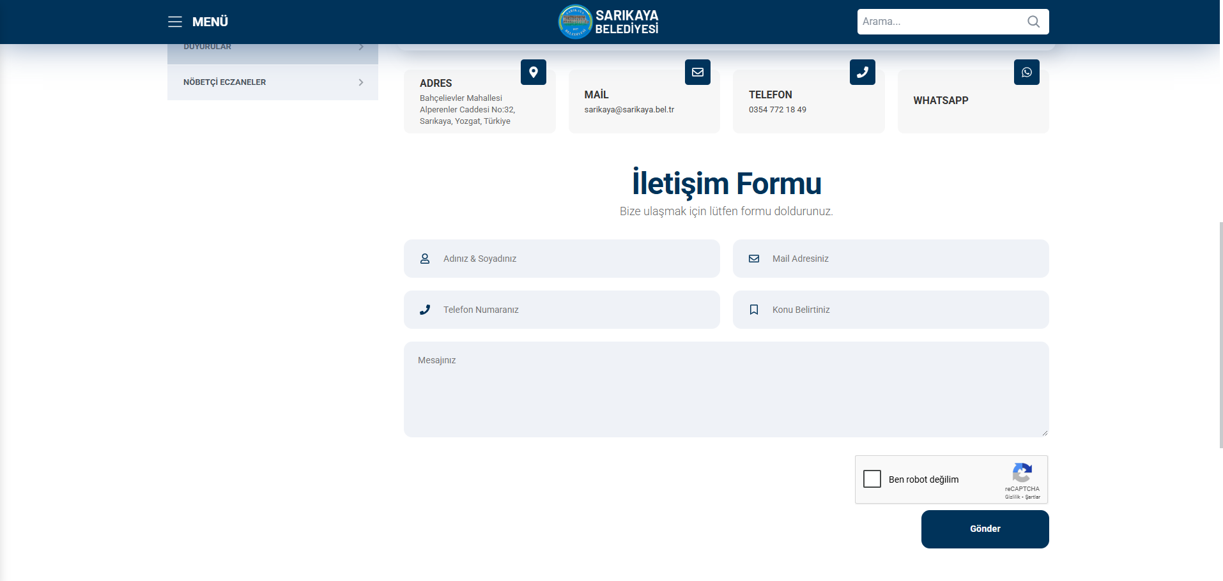
Figure 3. Sarıkaya Municipality Website
The grievances, requests, suggestions and opinions of the public will be recorded (See Annex- C) through the GM contact person (GMCP) to be assigned by Sarıkaya Municipality. Grievances can also be submitted anonymously, and such grievances will be evaluated with the same level of attention. In the case of anonymous grievances, while a direct response to the complainant may not be possible, the grievance will still be recorded and addressed. General feedback on such issues, including actions taken or policy changes made, will be disclosed publicly through appropriate communication channels such as the municipal website or public notice boards, without compromising confidentiality. All grievances are examined to be classified according to whether they are real or not and whether they are related to sub-project activities. If a grievance is deemed unsuitable for investigation because it is not genuine or not related to sub-project activities, the complainant will be provided with an explanation as to why the grievance could not be followed up. Appropriate grievances are responded to according to the sub-projects social and environmental requirements defined in the ESMP and SEP.
All grievances received through direct phone calls, e-mails, face-to-face meetings/communications and the Website are recorded and after the recording process, will contact the complainant to explain the sub-project response process and the resolution of the grievance within ten (10) business days. The development of the solution may require consultation with the relevant person(s). The requester will be informed about the methodology followed. Each request must be evaluated with the utmost care, diligence, fairness and impartiality. The proposed solutions are communicated to the complainant with a second notification.
If the proposed solution is accepted by the complainant, Sarıkaya Municipality PIU will handle the grievance within 15 business days and take corrective measures to resolve the grievance. Grievance registration forms will be sent to the relevant GM Team member (Social Expert of the PMU Team or E&S Expert of the Contractor) on the same day (if possible, as soon as the grievance is received). A notification should be sent to the complainant by GMCP within two (2) business days of the receipt of the grievance, indicating that the grievance has been received and evaluated.
The PMU Team will also have access to the grievance records to be created within the scope of the sub-project, and these records will be continuously updated by the GM Contact Person (GMCP) or the PIU Social Expert. The Grievance Tracking Table will include the information of the complainant/suggester, the date the grievance/suggestion was received, the date and method of feedback provided to the complainant, the current status of the grievance (open, under review, closed, rejected), and an explanation of this status (e.g., reason for rejection). Additionally, the table will include the closing/rejection date and feedback dates.
Grievances from contractors and subcontractors will be forwarded to the GMCP by the Contractor’s Environmental and Social Expert and will be recorded by the GMCP using grievance registration forms. On the same day, this data will be entered into the Grievance Registry and Grievance Database and made accessible to the PIU Team.
During this period, the relevant parties responsible for managing the grievance will be in constant communication with the complainant and all communication will be recorded in the GM system through the Consultation Forms (see Annex-D). The grievance will be closed after the implementation of the decision is completed. After the grievance is closed or resolved, the complainant will be informed with the third notification and the relevant records (Grievance Closure Form, Grievance Record, etc.) will be kept. Unless an alternative agreement is made with the complainant, grievances will be closed within thirty (30) business days from the date of application. If the grievances are not resolved within thirty (30) business days, the extenuating circumstances will be documented and reported. After the grievance is resolved and the result is communicated to the complainant, the appointed GMCP will obtain the necessary signatures and close the grievance by filling out the Grievance Close Out Form (see Annex-B). If the decision is not accepted, it will be reconsidered and a revised decision may be proposed. Ultimately, the PIUs will be responsible for consolidating, monitoring and reporting the requests received, resolved and pending regarding the project. All this data will be compiled by the PIU to be reported at the end of each month.
Sarıkaya Municipality/PIU Team will also implement additional measures to manage sensitive and confidential grievances, including those related to Sexual Exploitation and Abuse/Harassment (SEA/SH), in accordance with the World Bank ESF Good Practice Note on SEA/SH.

Sensitive and Confidential Grievances
Specific procedures will be implemented by the project in order to address sensitive and confidential grievances, particularly those that are related to Sexual Exploitation and Abuse/Harassment (SEA/SH). These measures will be implemented in accordance with the World Bank ESF Good Practice Note on SEA/SH.
First of all, the complaining party has the right to remain confidential under the Turkish Constitution and the right to apply to the court at any time (in accordance with the Turkish Labor Law No. 4857 and the Turkish Civil Code No. 4721). In addition, Sub-Borrower personnel and sub-project employees will be able to directly communicate (via e-mail) with the Ethics Committee based at İLBANK Head Office in case of sensitive grievances. This issue will be clarified in the consultations carried out and in the introduction of the grievance mechanism. For cases related to gender-based violence, SEA/SH in the workplace or any potential child abuse in sub-project implementation/sub-project sites, the grievance will be directed to the relevant legal authorities or service providers by the Social Focal Point (based at ILBANK Head Office).

Grievance Mechanism for Workers
The GM for employees (applicable to both Sarıkaya Municipality personnel and contractor and subcontractor employees) has been established in accordance with WB ESS2. The implementation of the GM for employees will be ensured throughout the financing life cycle of the sub-project. PIU requests contractors to develop and implement a grievance mechanism for the workforce, including subcontractors, before starting work. Subcontractors will prepare labor management plans that will include a detailed description of the grievance mechanism for employees.
Employees are informed about employee rights, basic occupational health and safety, the grievance mechanism and its operation at the time they start work. An up-to-date list of contact points is available in employee handbooks and/or bulletin boards. All processes related to the grievance mechanism are conveyed in a language that employees can understand. Employees are encouraged to use the grievance mechanism without fear of retaliation.
When employees detect a hazard or risk for which no precautions have been taken regarding occupational health and safety, they inform the employee representative, occupational safety specialist and/or occupational physician selected by the employees about this hazard or risk. The employee representative shall forward the details of the hazard and risk to the occupational health and safety board, if any, or to the employer/employer's representative, and request an evaluation. If the problem is not resolved, all legal rights are reserved by applying to the contractor/subcontractor level GM contact persons through the grievance boxes located at the workplaces. Requests regarding employee rights and occupational health and safety are collected in complaint boxes placed in areas that employees can easily access.
The collected complaints and suggestions are carried out in accordance with the periods determined in the basic process of the grievance mechanism.
After the applications are evaluated, if there is an imminent, urgent and vital danger, a notification can be made directly to the Labor Life Communication Center, ALO 170 line or the Provincial Labor and Employment Institutions Directorates operating in the province. Upon receipt of the requests, the workflow grievance mechanism is carried out in accordance with the workflow chart.
The Sarıkaya Municipality/PIU Team will be ready to handle complaints regarding working conditions. The Sarıkaya Municipality/PIU Team will evaluate complaints and suggest solutions for direct and contracted employees using this internal GM, which all sub-project employees can easily access.

Grievance Mechanism Flow Chart
Grievance mechanism operation diagram details are given in Table 7.

Table 6. Grievance Mechanism Flow Chart
Grievance Process | Requirement / Action
Submission of a grievance | Receiving the grievance by any communication channel explained above. (At this point, if the grievance is a sensitive grievance involving child abuse, sexual harassment abuse or Gender Based Violence (GBV) immediate action will be taken within 2 days after receiving of the grievance. For the cases relevant to sexual exploitation and abuse/sexual harassment at workplace or any potential child abuse in the project sites, the grievance will be directed by the GM focal point (based in ILBANK headquarter) to relevant legal authorities/service providers such as Ministry of Family and Social Services and Prosecutors Office.”)
Registration of grievance | Registering/recording through making an entry in the sample grievance register table. All the grievances will be registered within two working days and feedback will be given to the complainant. If the complainant requests that this grievance be treated anonymously, this grievance will be recorded anonymously and the request will be met.
Forwarding of grievance | The grievance is forwarded to relevant persons (site manager on construction sites and experts of the PIU) responsible for handling the grievance in not later than three working days upon receiving the grievance (except for any emergent grievance, which would be handled as appropriate).
Evaluation of a grievance | Evaluating the grievances within 10 working days and determining whether the grievance meets the admissibility criteria. If the grievance is not valid, providing relevant explanation to the complainant.
Response for a grievance | If the grievance is valid, identifying and taking corrective measures for resolving the grievance in not later than 15 working days upon receiving.  All comments and grievances will be responded to either verbally or in writing, in accordance with the preferred method of communication specified by the complainant, if contact details of the complainant are provided.  At this point, it should be noted that the action taken and the result of this anonymously recorded grievance should be shared on the Sarıkaya Municipality website, so that anonymous complainants is informed about their grievance and the results.
Recording the result of a grievance | Recording the result of the grievance in register table.
Right to Appeal | If the grievance cannot be resolved with the existing process, applicants can always apply to relevant legal institutions. Such institutions can be summarized as follow:  - Civil Courts of First Instance  - Administrative Courts  - Commercial Courts of First Instance  - Labor Courts, and  - Ombudsman (https://ebasvuru.ombudsman.gov.tr/)

MONITORING AND REPORTING

Summary of how SEP implementation will be monitored and reported
It is the responsibility of Sarıkaya Municipality to ensure that the SEP is fully integrated and implemented in all sub-project activities. All stakeholders will be consulted and will be able to use the GM throughout the sub-project lifecycle. On the other hand, the SEP will form part of all tender documents related to the physical works within the scope of the sub-project.
In line with İLBANK’s ESMS and the World Bank’s ESF requirements, the draft ESMP and draft SEP will be disclosed to the public once they are approved for disclosure by İLBANK. The responsibility for this disclosure lies with the Sarıkaya Municipality. The SEP must be made available both in hard copy and on the official website. Similarly, several copies of all prepared environmental and social documents will be available locally in Sarıkaya Municipality, where affected groups such as the Mukhtar offices operating in the Central District of Sarıkaya Province and local NGOs can easily access.
The SEP is a dynamic document and will be reviewed, updated and approved by ILBANK when necessary (e.g. changes in the design of sub-project components according to Environmental and Social Monitoring Reports (ESMRs), stakeholders' requests/grievances regarding the sub-project. Implementation of the SEP throughout the implementation of the sub-project, elimination of non-conformities, etc.). Sarıkaya Municipality will be responsible for making a statement through communication channels for each updated version of the SEP.
Sarıkaya Municipality will monitor the sub-project throughout its lifetime considering the stakeholder engagement process. The approved SEP will be reviewed biannually and updated if required according to the sub-project improvements and the unexpected public reactions. The GM established by the Sarıkaya Municipality will be used effectively and the statistical summary of the outputs of GM will be reported to ILBANK together with all the requests received, resolved and unresolved, Grievance Register, Grievance Monitoring Table and Environmental and Social Monitoring Reports (ESMRs) on a monthly basis. With monthly reporting, total number of grievances, monthly number of grievances, distribution of grievances by subject, gender, grievances answered within 1 days, grievances resolved within 30 days, list etc. is necessary.

Reporting back to stakeholder groups
The PIU Team will systematically record and report feedback received from communities, local governments, landowners, other companies, NGOs, media, academic institutions and other interest groups through an effective consultation and grievance mechanism to ILBANK. Reports will include not only the number and type of grievances received, but also how these grievances and stakeholder inputs have influenced project decisions and mitigation measures.
The PIU Team will submit feedback and grievances, as well as a statistical and qualitative analysis of their results, to the Supervisory Consultant on a monthly basis, who will review and distribute them to ILBANK PMU. In addition, relevant grievances and their actual status will be reported in the ESMRs. Only the necessary information regarding the grievance will be included in the reports, and any personal information belonging to the persons using the ESMR will be kept confidential and will not be shared in these reports.
During the sub-projects’ development and construction phases, the construction contractors will prepare brief monthly reports on environmental and social performance for Sarıkaya Municipality which will include an update on implementation of the stakeholder engagement plan and include indicators in this section. The construction contractors will record SEP activities with monthly and quarterly reports and submit them to Sarıkaya Municipality and ILBANK.
Sarıkaya Municipality’s PIU, will report back to stakeholder groups, primarily through public engagement meetings in project affected municipalities and/or Neighborhoods. Summaries will be published on the municipal website, ensuring that information is accessible, understandable, and timely. Feedback received through the GM will be responded to in writing and verbally. Key sub-project updates will be posted on Sarıkaya Municipality's website.
The summary will be published after the identity information of the persons is removed in order to protect their identity in accordance with the Personal Data Protection Law.
Sarıkaya Municipality will work with a consultant if necessary to carry out social and environmental monitoring activities. The Supervisor Consultant will monitor whether the environmental and social issues specified in the SEP and ESMP documents are implemented throughout the sub-project lifecycle and report to Sarıkaya Municipality.
During the construction phase, there will be no road closures or infrastructure service limitations. Therefore, voice announcements by Sarıkaya Municipality and/or Contractors regarding such restrictions will not be necessary. Environmental and social performance indicators will be shared with stakeholders monthly via Sarıkaya Municipality's website.

ANNEXES

Annex-A
Sample Grievance Form

 |  | SARIKAYA MUNICIPALITY  SOLAR POWER PLANT PROJECT
 |  | GRIEVANCE FORM
Person Filling Out the Form: |  |  |  |  | Date and time:
Inteview Agenda: |  |  |  |  | Reference No: Sarıkaya Municipality-Project Code-0001-2..
- INFORMATION ABOUT THE COMPLAINANT
Name surname:  If the complainant requests that this complaint be treated anonymously, this complaint will be recorded anonymously and the request will be met. |  |  |  |  | How received the Grievance:
TC Identification number: |  |  |  |  | Telephone / Toll Free Line
Telephone: |  |  |  |  | Face to Face Meeting
Address: |  |  |  |  | Website / Email
Email: |  |  |  |  | Other (Explain)
Stakeholder Type
Public | PAP |  | Private Enterprise | Trade Association |  | NGO
Interest Groups | Industrial  Association |  | Labor Union | Media |  | University
- DETAILED INFORMATION ABOUT THE GRIEVANCE
Description of the grievance:
Solution method requested by the complainant
Registrant Name Surname/Signature |  | Complainant Name Surname/Signature

Annex-B
Sample Grievance Close Out Form

SARIKAYA MUNICIPALITY

SOLAR POWER PLANT PROJECT
 | GRIEVANCE CLOSE OUT FORM
Reference form:
- DETERMİNATİON OF CORRECTIVE ACTION
1
2
3
4
5
- CLOSE OUT THE GRIEVANCE
This section will be filled and signed by the Complainant in case the grievance stated in the “Grievance Registration Form” is resolved
Name Surname /  Signature of the Person  Closing the Complaint/Date | Name Surname /  Signature of Complainant/Date

Annex-C
Grievance Database Form

No | Grievance Register  Number | How Grievance is Received (Grievance Form, Community Meeting, Telephone) | Level of Grievance (Municipality/Utility Level, Regional) | Date of Grievance  Received | Location of Grievance  Received | Name of Person Receiving Grievance | Land Parcel #  (If grievance is related to land) | Complainant Information |  |  |  |  | Project Component Related to Grievance | Grievance Category (expropriation/land acquisition related, environmental issues, damages to structures etc.) | Grievance Summary | Grievance Status (open, closed or pending) | Action Taken |  |  |  | Supporting Documents for Grievance Closeout (bank receipt for compensation, grievance closure protocol)
 |  |  |  |  |  |  |  | Name/Surname | ID Number | Telephone/  email | Village-District | Gender |  |  |  |  | Responsible Person/Department | Action Planned | Due Date of the Addressing the Grievance | Date of Action Taken
1

Annex-D
Sample Consultation Form (For Stakeholder Participation Meeting(s))
SARIKAYA MUNICIPALITY

SOLAR POWER PLANT PROJECT
 |  | CONSULTATION FORM
Person Filling Out the Form: |  |  |  | Date time and place:
Meeting Agenda: |  |  |  | Interview Registration Number: Sarıkaya Municipality/Project Code-0001-2..
- INTERVIEW INFORMATION
Interviewed Institution: |  |  |  | Form of Communication
Name and Surname of the Interviewee: |  |  |  | Telephone / Toll Free Line
Telephone: |  |  |  | Face to Face Meeting
Address: |  |  |  | Website / Email
Email: |  |  |  | Other (Explain)
Stakeholder Type
State agency | PEB | Private Enterprise | Job Room |  | NGO
Interest Groups | Industrial Unions | Labor Union | Media |  | University
- INTERVIEW DETAILS (List of Invitees and actual participants, Summary of presentations made by whom, minutes of meeting will be annexes of this form.)
Questions about the project:
Concerns/feedback regarding the project:
Responses to the views expressed above:

Annex-E
Field Interviews
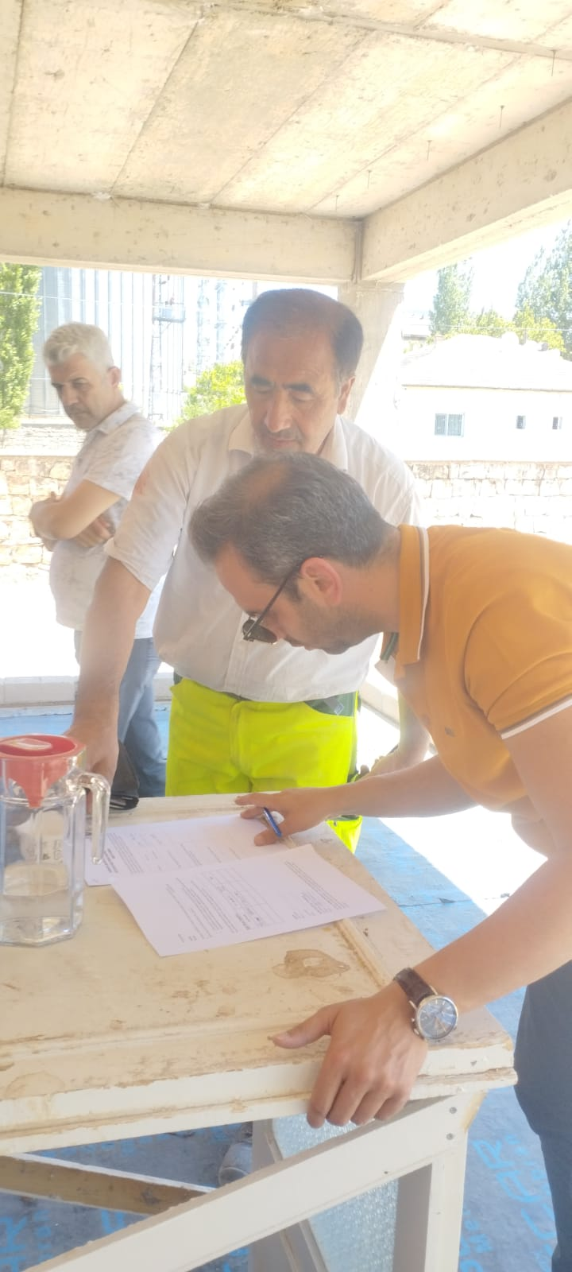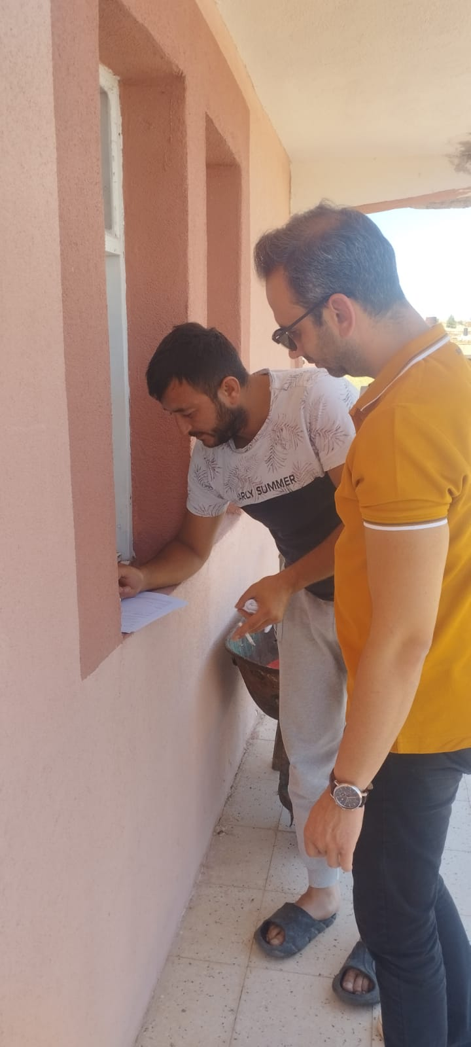
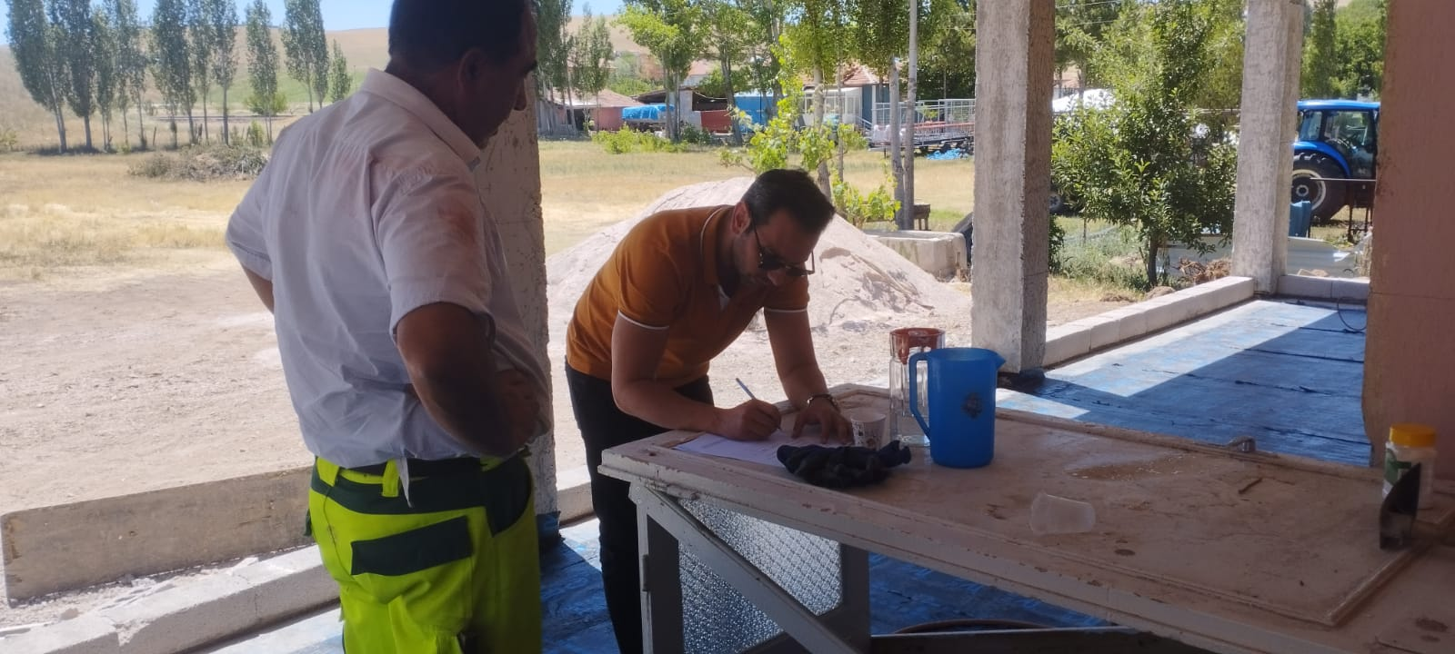
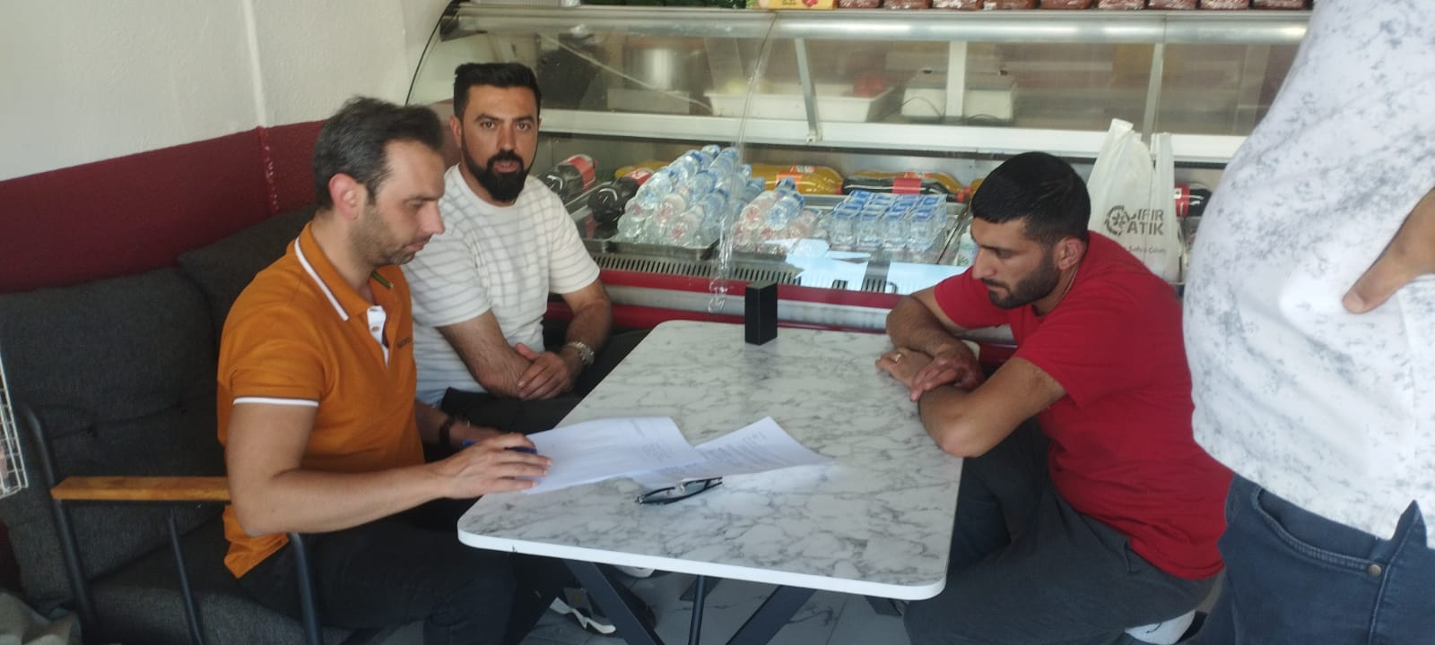

Annex-F
Community Level Survey Form
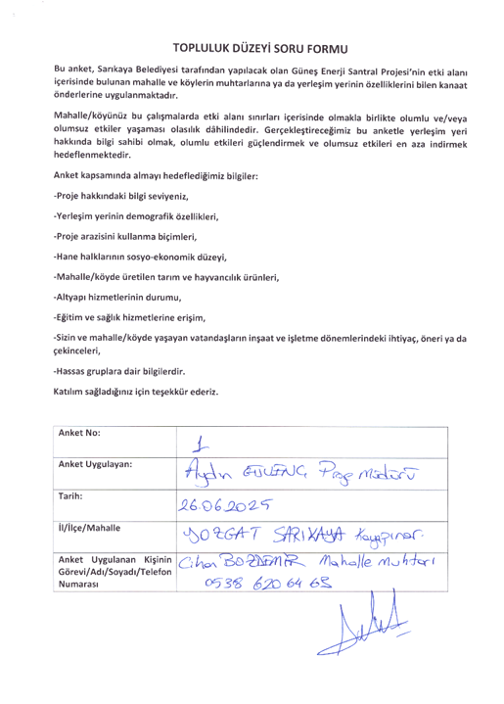
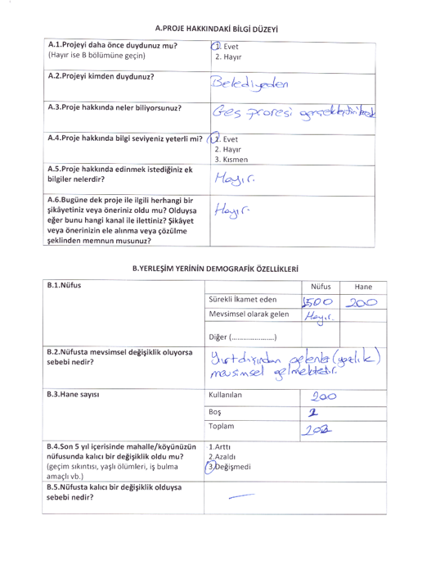
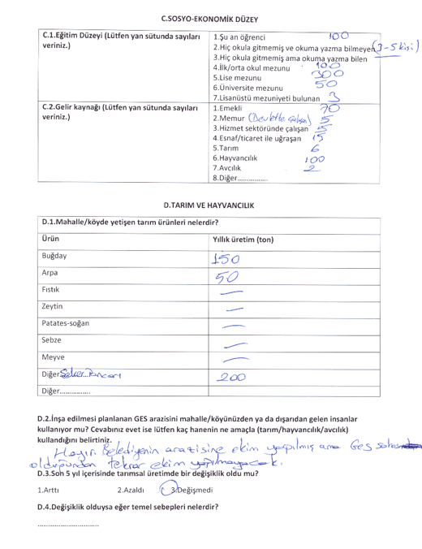
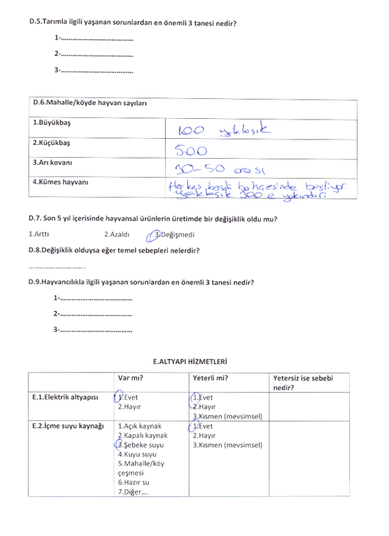
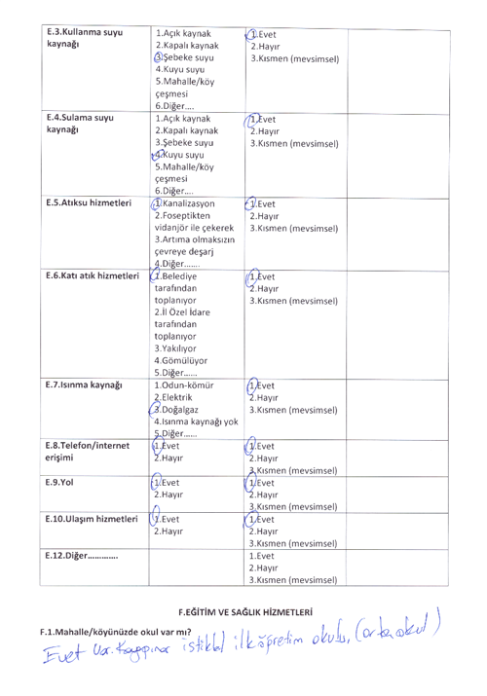
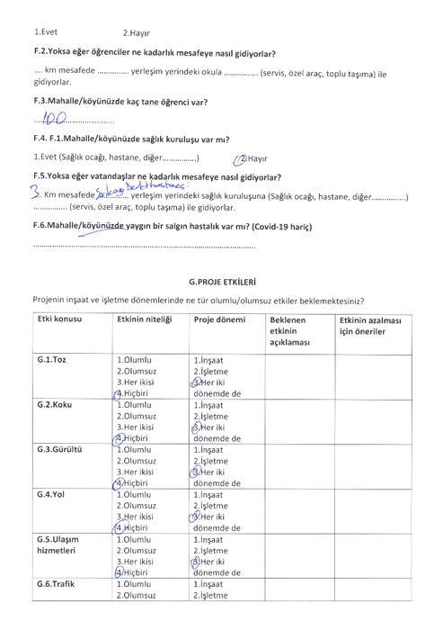
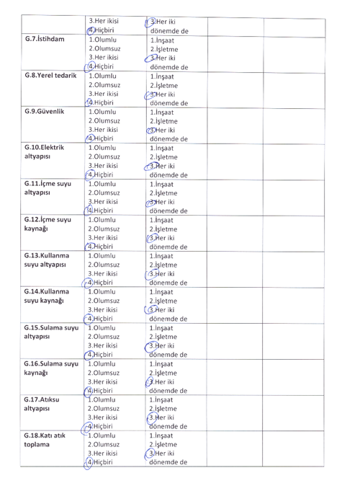
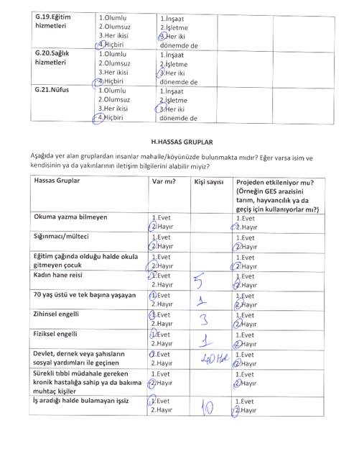

Annex-G
Agreement with Neighboring Landowners on Temporary Agricultural Spillovers
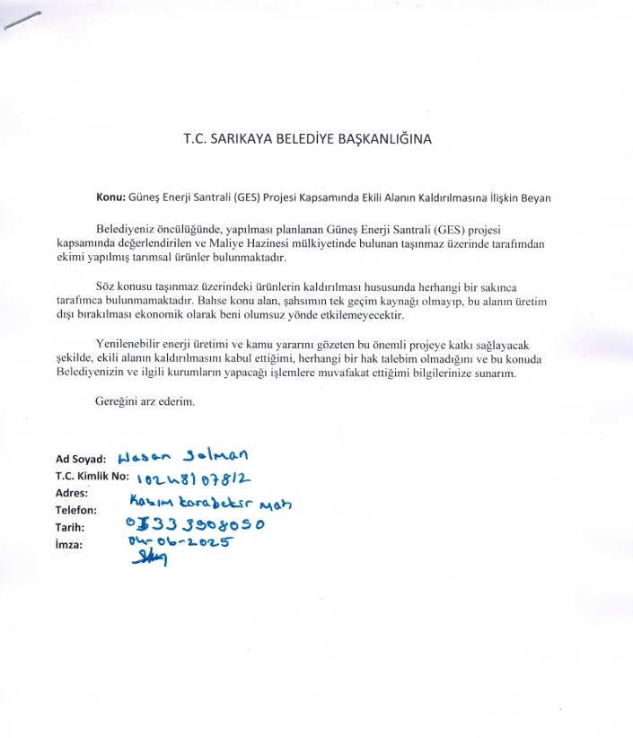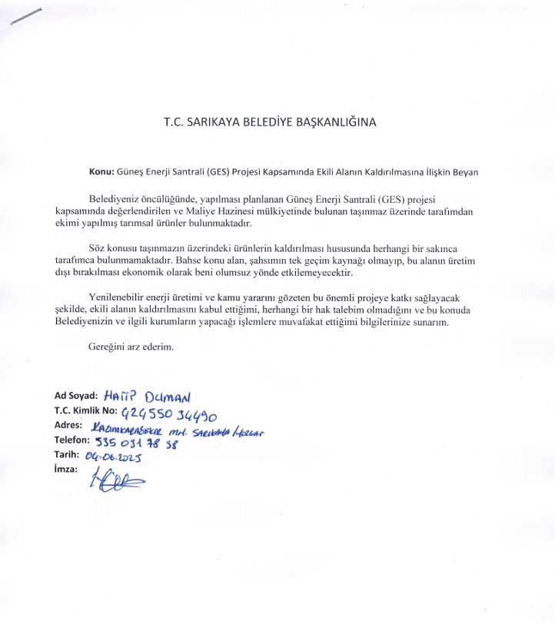

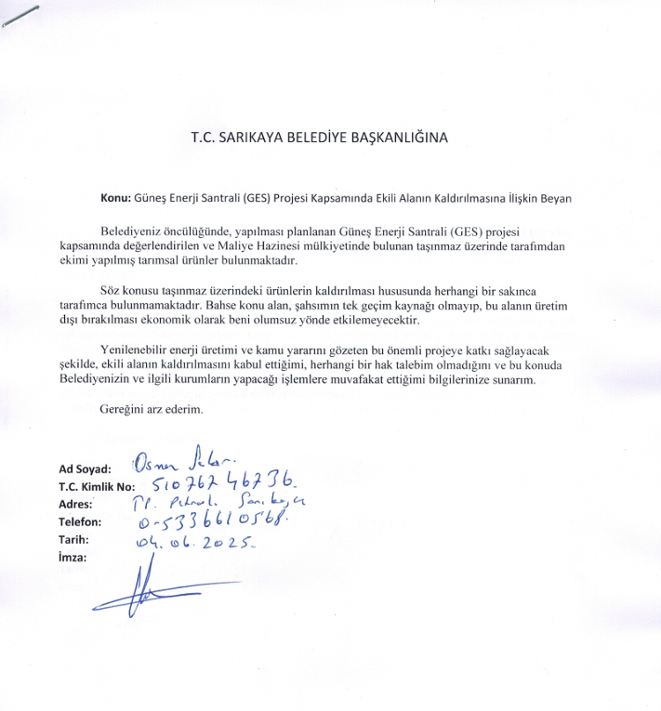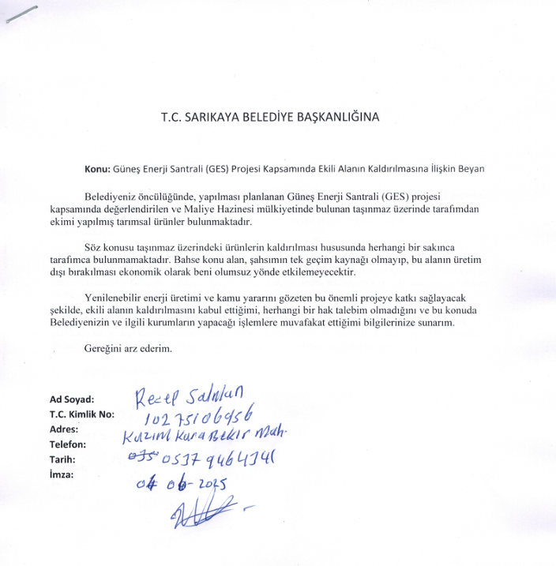

Annex-H
Sarıkaya Municipality’s Assurance on Agricultural Lands
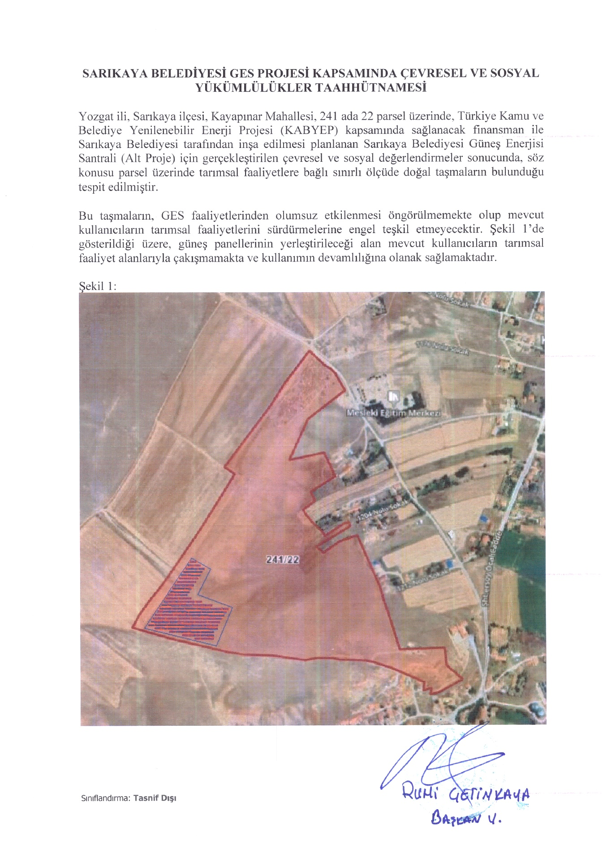
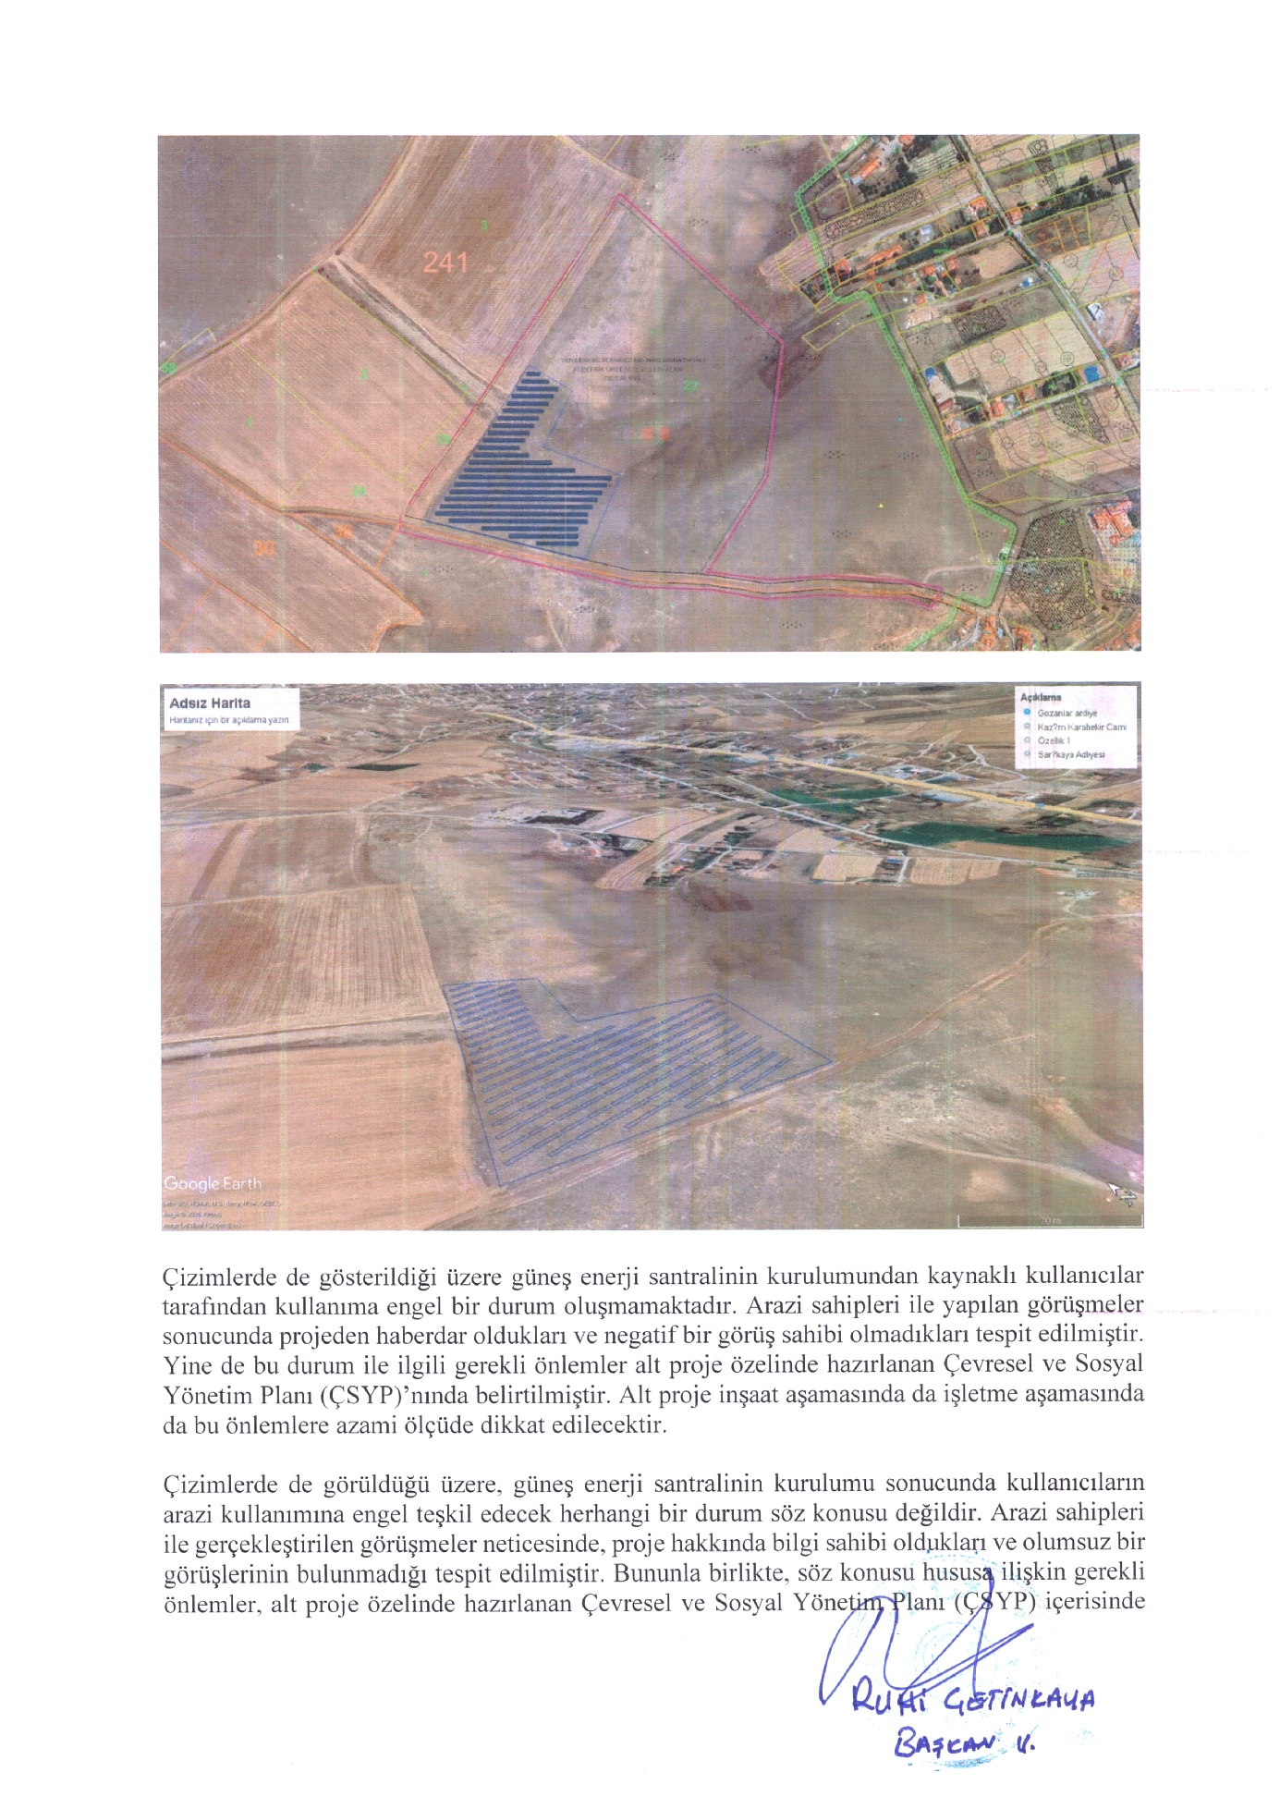
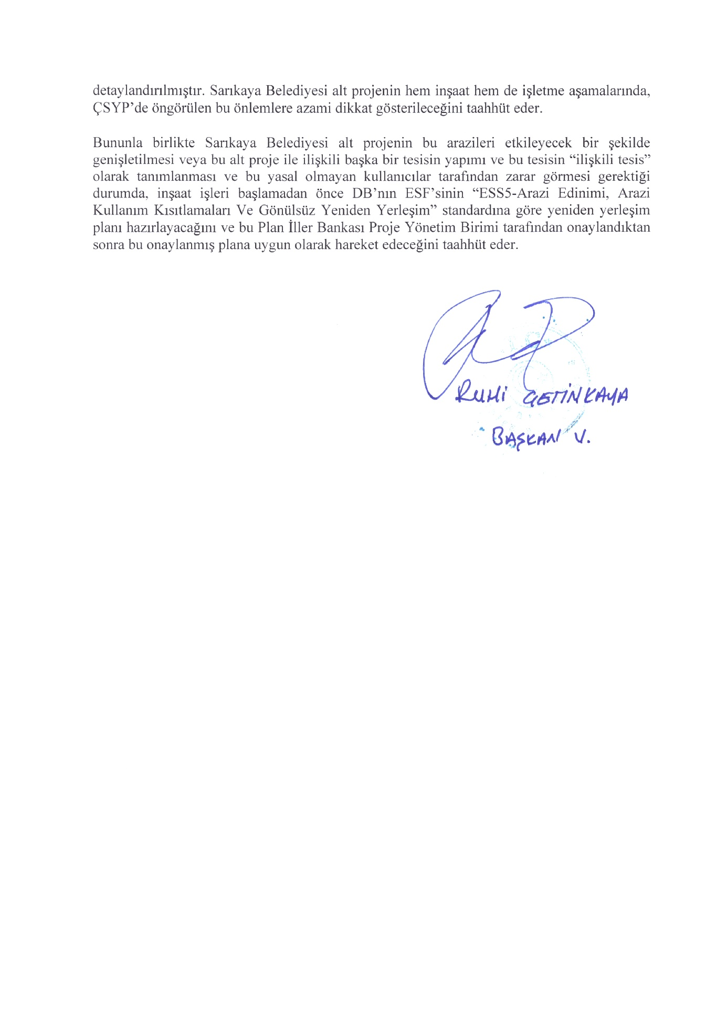

Annex-I
Minutes of Stakeholder Consultation Meeting

TÜRKİYE PUBLIC AND MUNICIPAL RENEWABLE ENERGY PROJECT (PUMREP)

SARIKAYA MUNICIPALITY
SOLAR POWER PLANT PROJECT

Minutes of Stakeholder Consultation Meeting

Meeting Date: 23.12.2025
Meeting Time: 14:00
Meeting Venue: Kayapınar Condolence House
STAKEHOLDER CONSULTATION MEETING
The Sarıkaya Municipality Solar Power Plant (SPP) Project is one of the sub projects developed under the Türkiye Public and Municipal Renewable Energy Project (PUMREP), which aims to support sustainable development in cities across Türkiye. Within the scope of the subproject, the ESMP and SEP have been prepared in accordance with Türkiye’s applicable environmental and social legislation, the World Bank ESSs, and the İLBANK ESMS.
In order to ensure public disclosure and meaningful stakeholder engagement, a Stakeholder Consultation Meeting was held on 23 December 2025 at 14:00 at the Kayapınar Condolence House. Prior to the meeting, printed information materials, including brochures and posters, were prepared and distributed to inform the local community.
Meeting announcements were disseminated through the neighborhood mukhtars of Kayapınar, and brochures were distributed directly to citizens. In addition, announcements were posted at various accessible locations across Sarıkaya district, including mosques, condolence houses, bus stops, and other public facilities.
Furthermore, the meeting announcements were publicly disclosed via the official website and social media accounts of Sarıkaya Municipality, as well as through local and national newspapers.

Meeting Summary
The Stakeholder Consultation Meeting commenced with an opening speech providing an overview of the objectives of the Sarıkaya Municipality Solar Power Plant Project, its scope under PUMREP, and its anticipated local benefits. This was followed by a presentation delivered by the project manager and social specialists of the consulting firm on the Environmental and Social Management Plan (ESMP) and Stakeholder Engagement Plan (SEP) prepared for the sub-project. The presentation addressed the key environmental and social risks, corresponding mitigation measures, and the expected benefits of the project.
The meeting was attended by 19 local residents from Kayapınar Neighborhood. All participants were male.
During the meeting, participants shared their views and raised questions regarding the implementation process and potential impacts of the project. The questions raised by the participants were addressed in detail by the specialists of the consulting firm, and participants’ comments and expectations were duly noted.
Participants were also informed about the grievance redress mechanism, including the channels available for submitting comments, suggestions, and complaints throughout the sub-project lifecycle.
Overall, the meeting was conducted in an open and constructive manner, allowing for a mutual exchange of views between the project team and local stakeholders. The meeting concluded with a question-and-answer session and lasted approximately one hour.
The presentation delivered during the meeting is provided in Annex-7.

Question and Answer Section
Question 1
Name / Occupation | Resident of Kayapınar Neighborhood
Will households benefit directly from the electricity to be generated?
Answer 1
Name / Occupation | Project Manager – ÇA Engineering
The electricity to be generated under the Sarıkaya Municipality Solar Power Plant Project will primarily be used to meet the energy needs of municipal service buildings and facilities. In this context, the generated electricity will not be supplied directly to individual households. However, by reducing the municipality’s electricity expenditures, the project will help create savings in public resources, which will indirectly contribute to the improvement of public services provided across the district.

Question 2
Name / Occupation | Resident of Kayapınar Neighborhood
We carry out grazing and livestock activities in areas close to the project site. What measures are planned to prevent animals from entering the Solar Power Plant (SPP) site?
Answer 2
Name / Occupation | Social Expert – ÇA Engineering
In order to ensure the security of the Sarıkaya Municipality Solar Power Plant (SPP) site and to prevent any adverse impacts on livestock grazing activities in the surrounding areas, several measures are planned. Within this scope, the SPP site will be enclosed with perimeter fencing of adequate height to prevent animal entry, and controlled access points will be established.

In addition, security personnel will be stationed on-site on a 24-hour basis. These measures aim to ensure the safety of the facility while allowing livestock grazing activities in the surrounding areas to continue in a safe and uninterrupted manner.

Meeting Conclusion
The Stakeholder Consultation Meeting, which lasted approximately one hour, commenced with a presentation delivered by the project manager and social expert of the consulting firm, providing information on the studies conducted within the scope of the subproject and the overall subproject process. This was followed by a question-and-answer session during which participants’ views, questions, and requests were received.
Throughout the meeting, information was shared regarding the environmental, social, and economic aspects of the Sarıkaya Municipality Solar Power Plant Project, as well as the current status of the subproject and its next phases. In addition, participants were informed about the grievance mechanisms available for submitting opinions, suggestions, and complaints throughout the subproject lifecycle.

Participant List
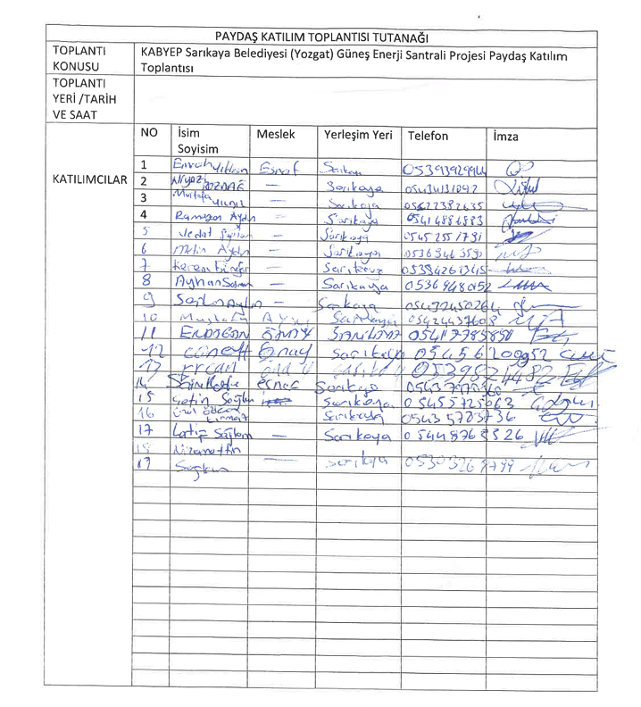

ATTACHMENTS

Annex-1: Photo of the Stakeholder Consultation Meeting (23.12.2025)
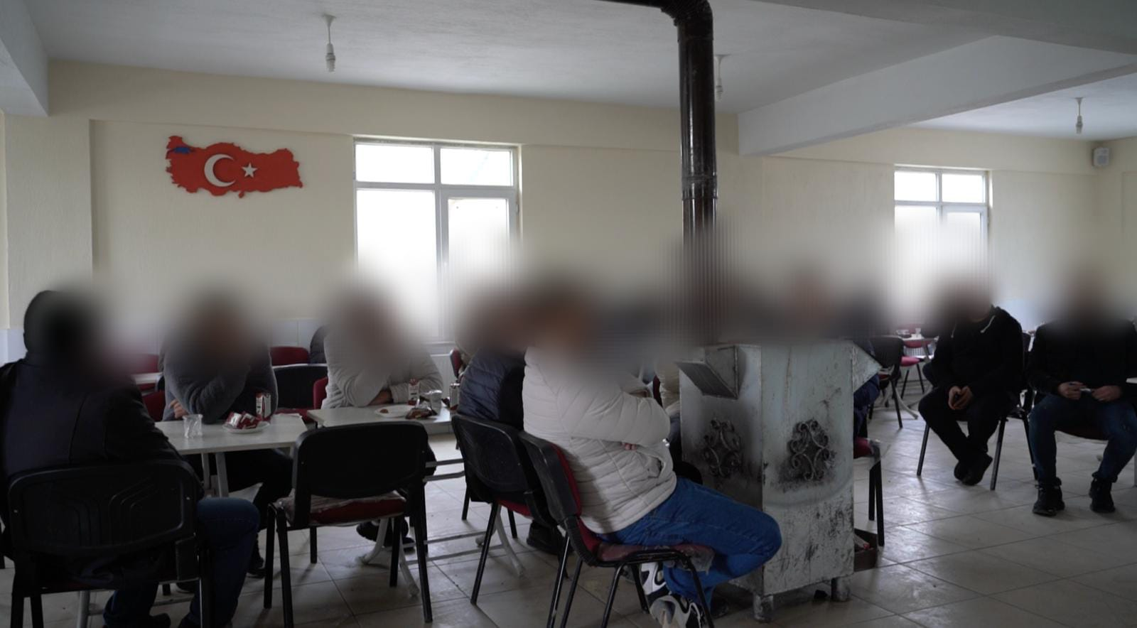
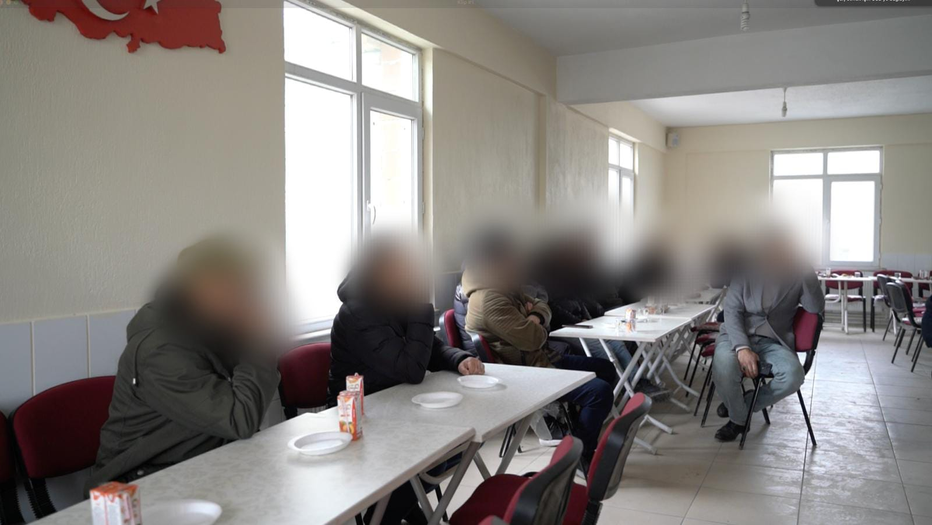
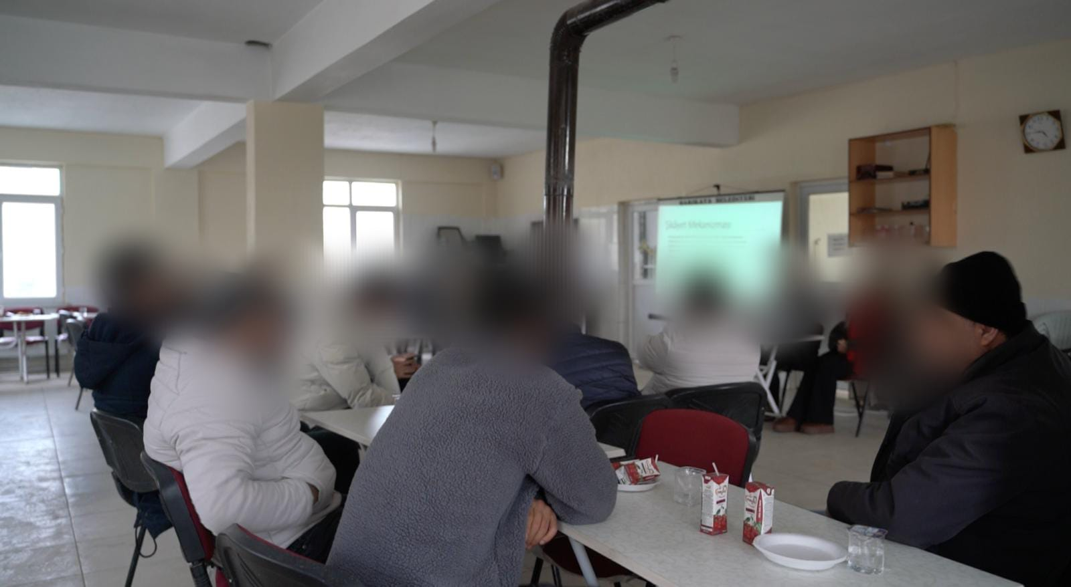

Annex-2: National Newspaper Advertisement (Newspaper Announcement Date –Türkiye 11.12.2025)
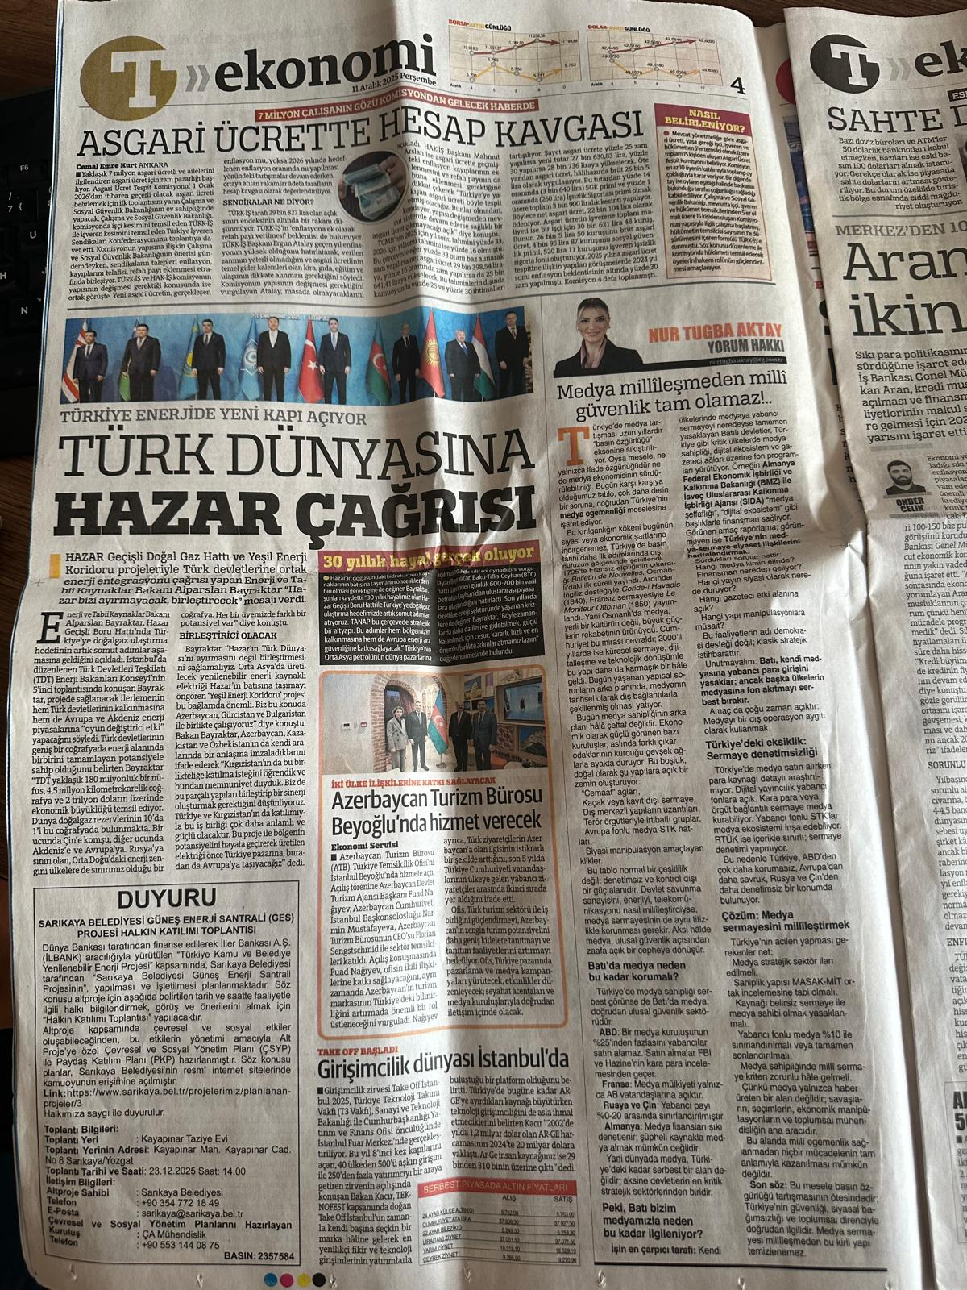

Annex-3: Local Newspaper Advertisement (Newspaper Advertisement Date – Yöre Newspaper -12.12.2025)
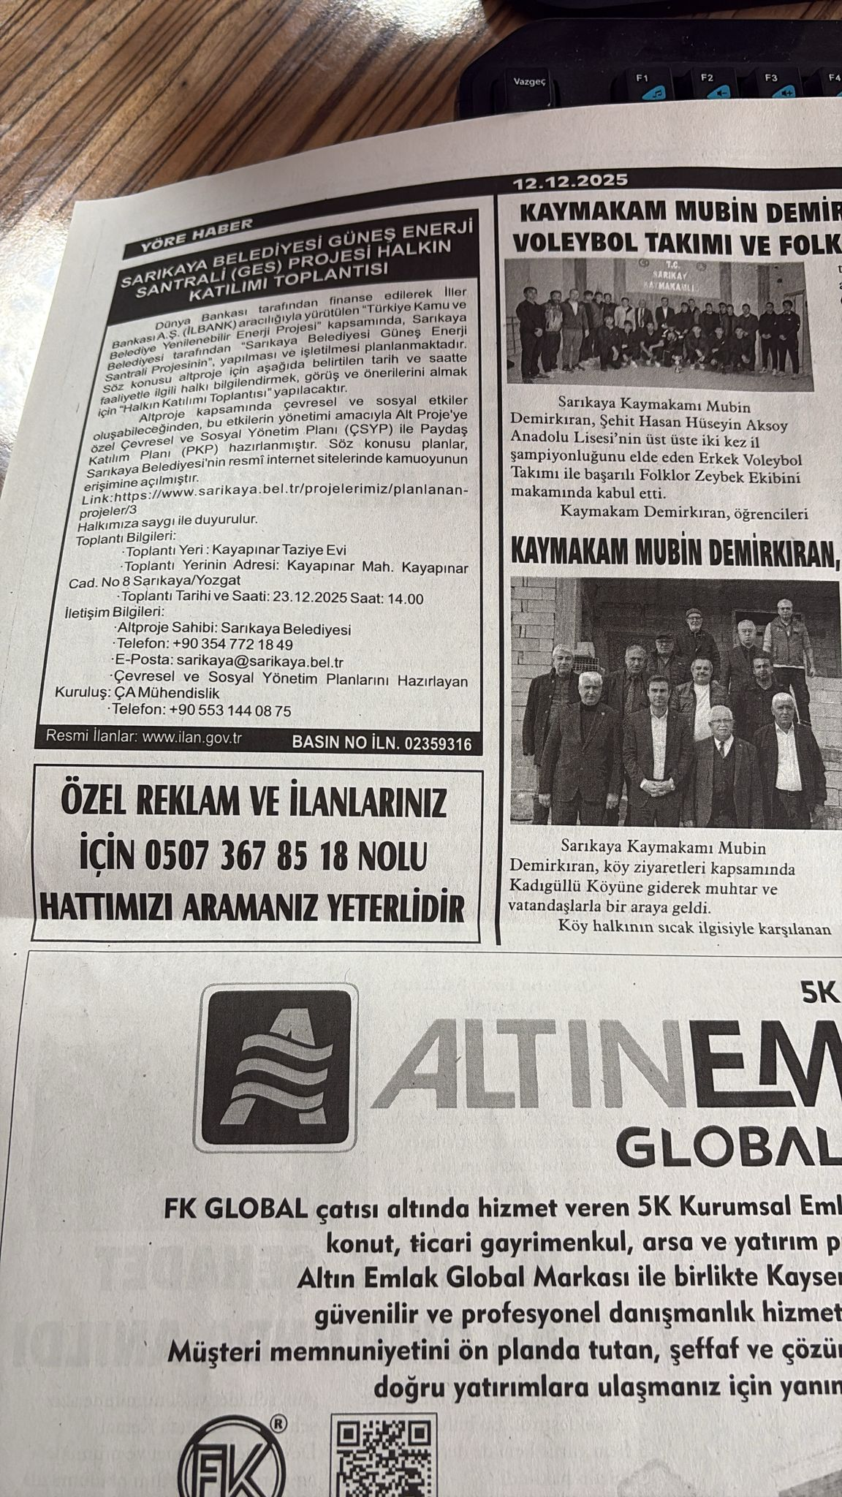

Annex-4: Sarıkaya Website, Announcements (08.12.2025)
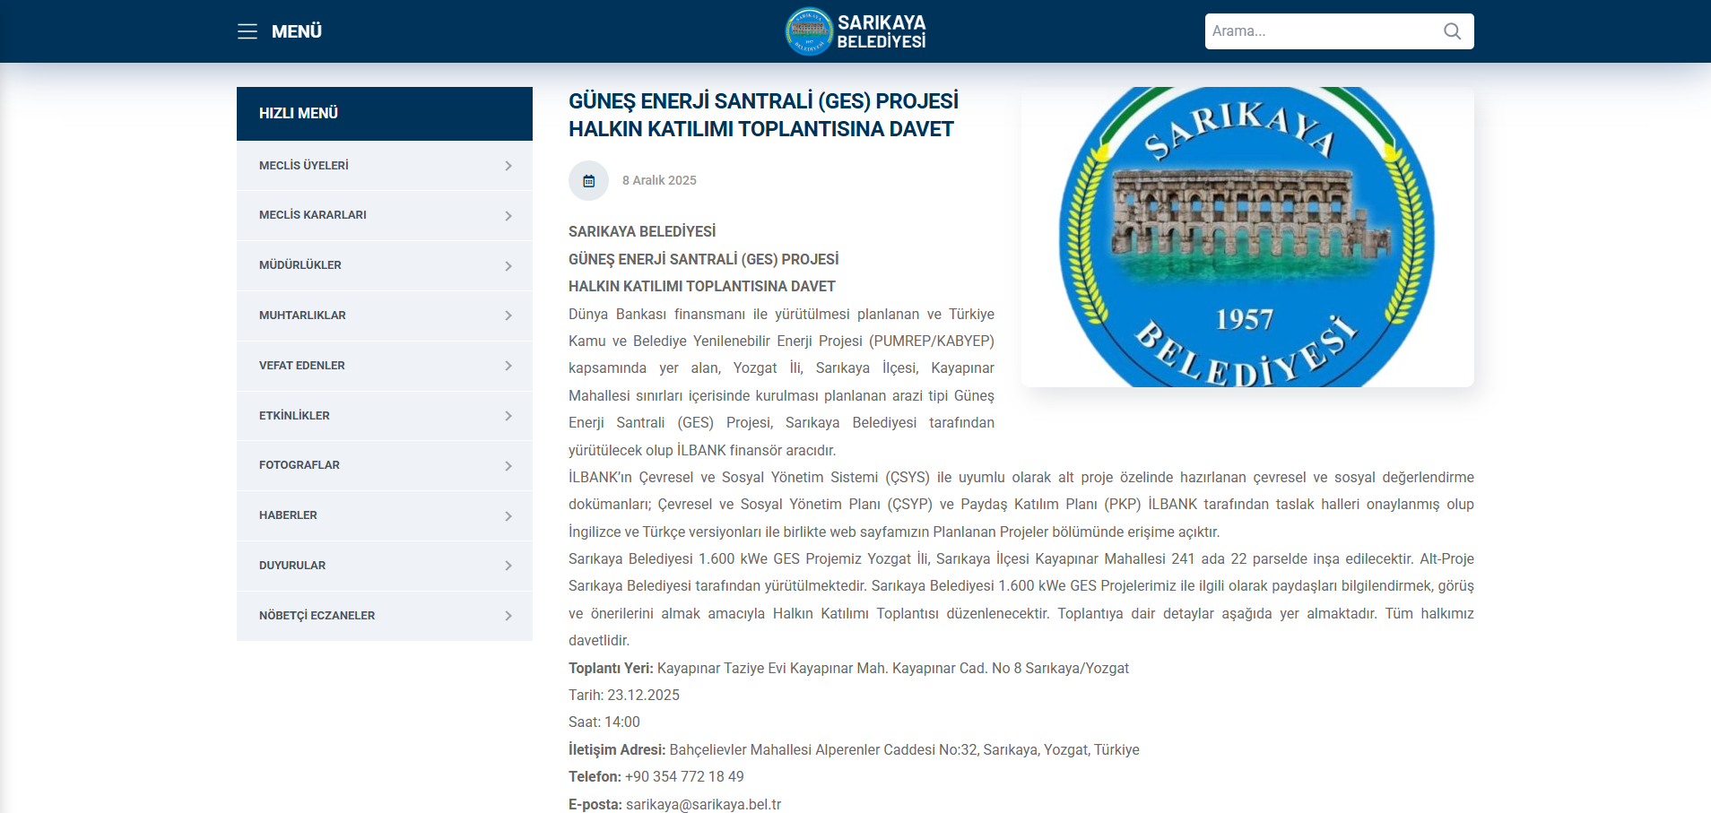

Annex-5: Distribution and Posting of Brochures
Announcements Posted at Neighborhood Mukhtar Offices and Other Publicly Frequented Areas
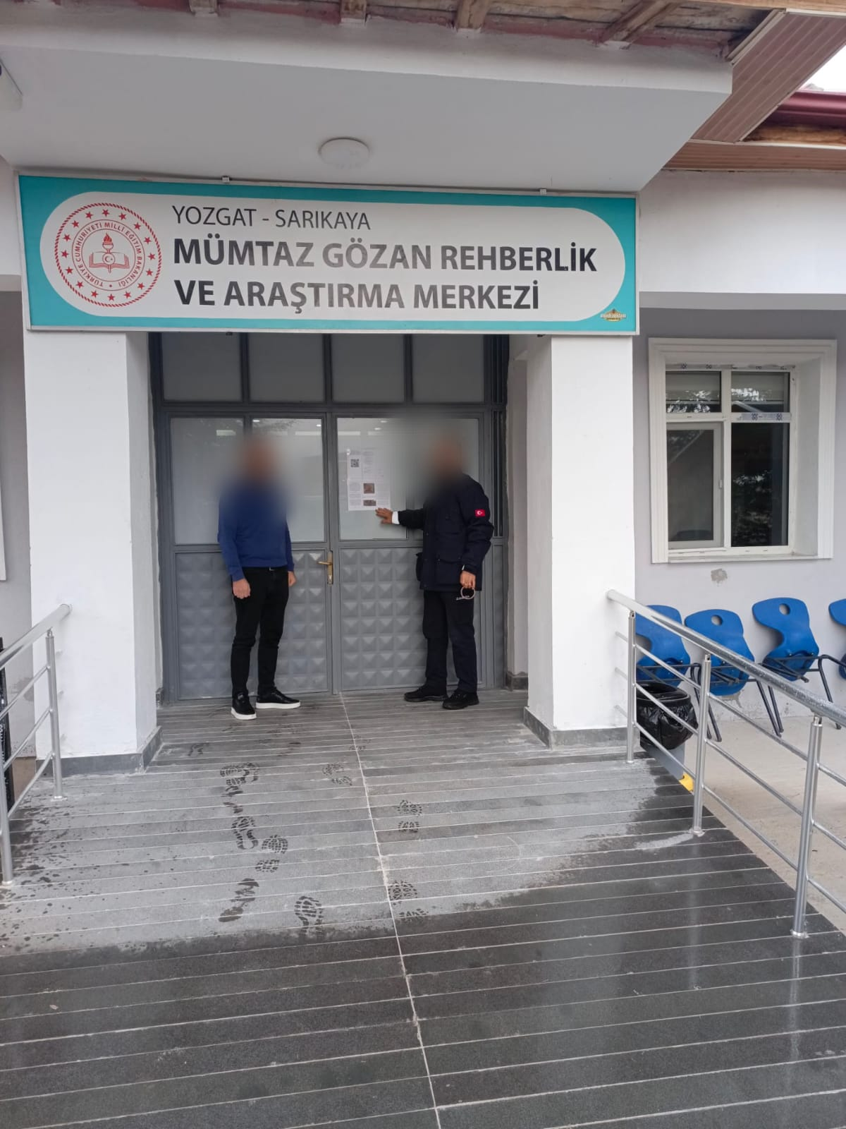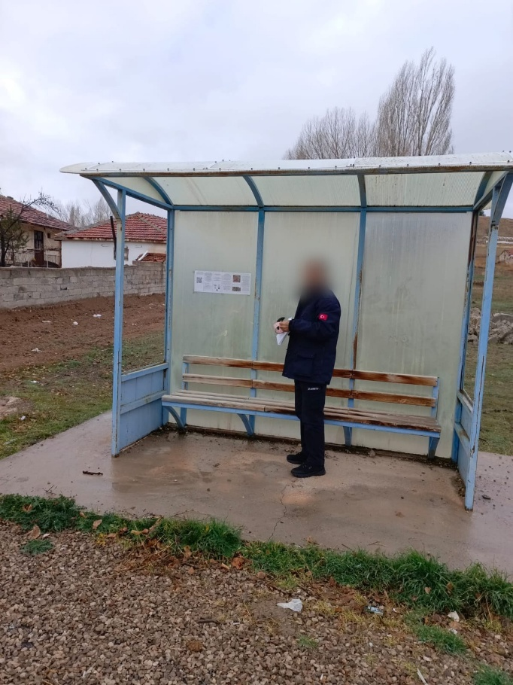
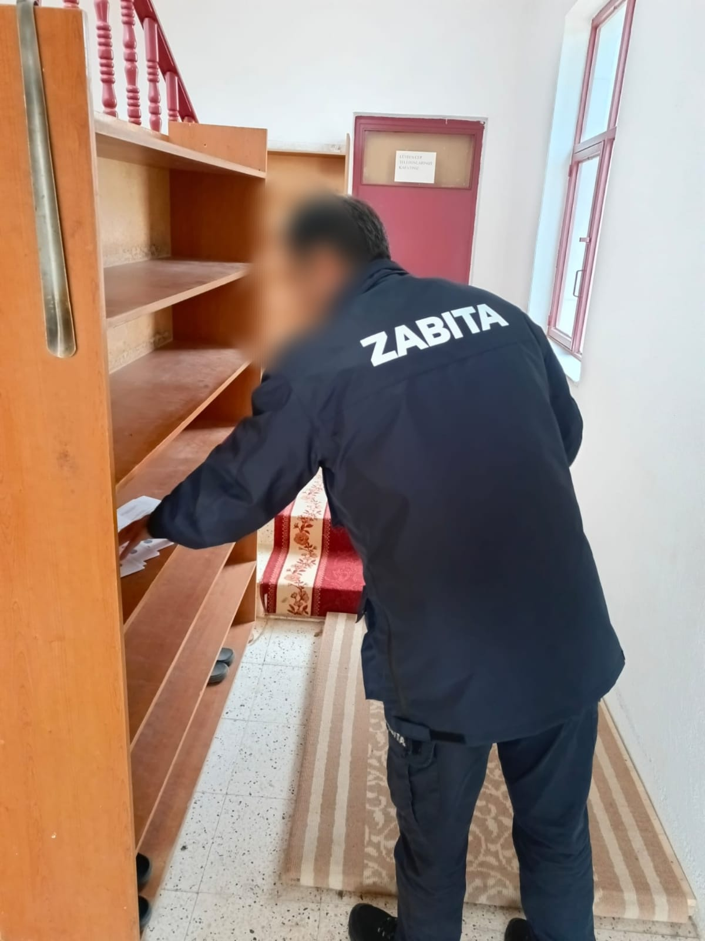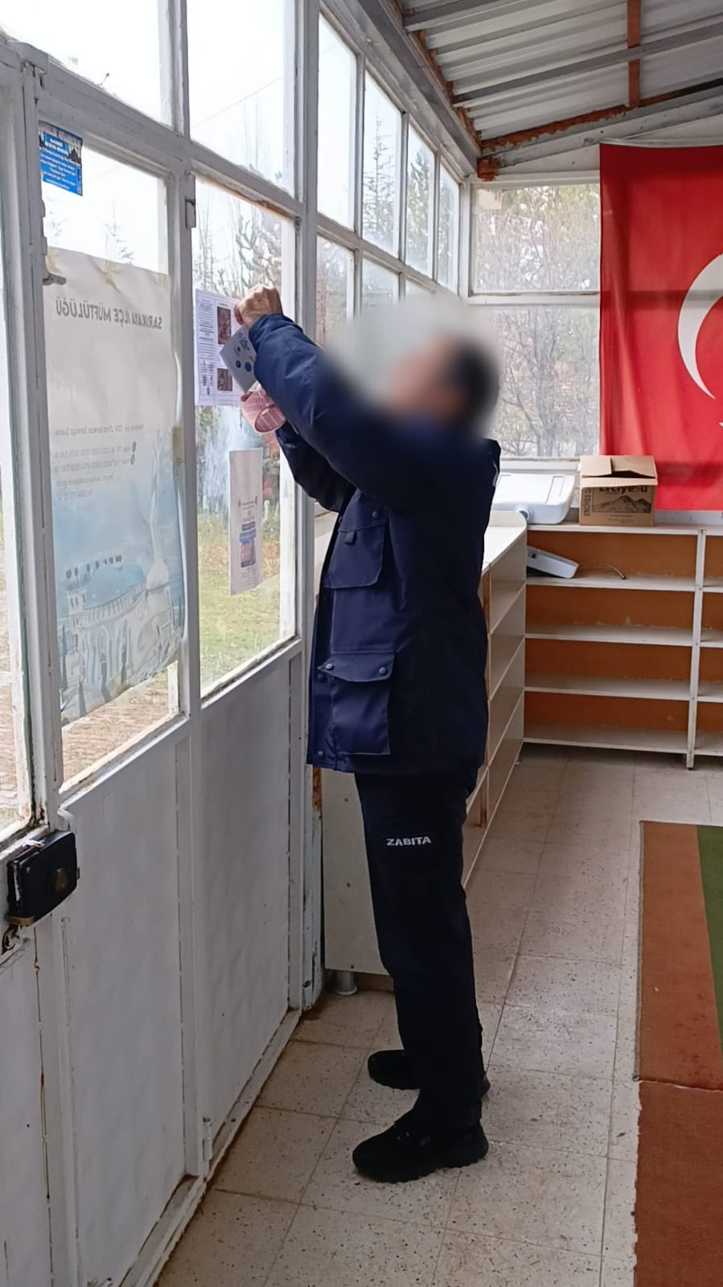
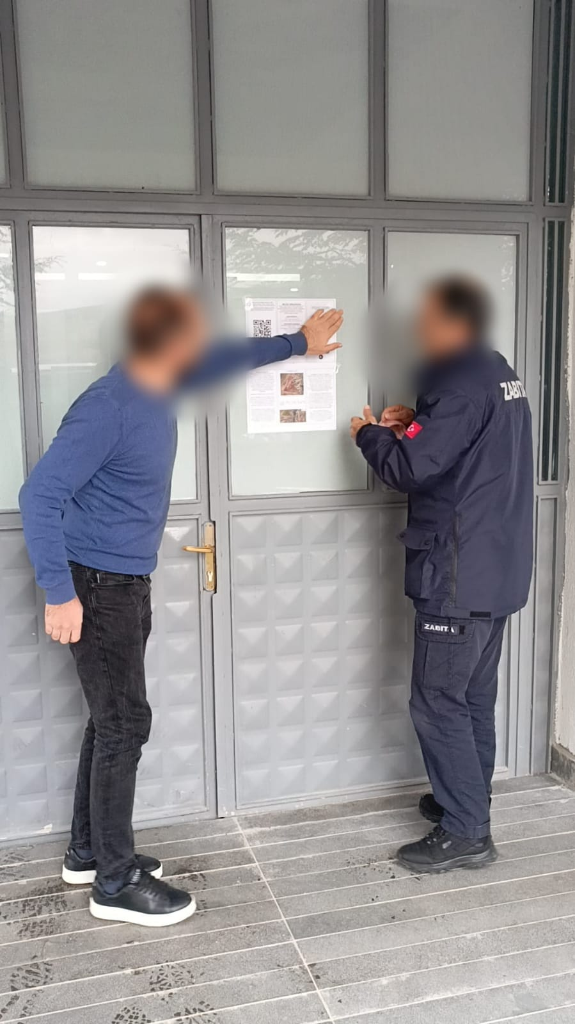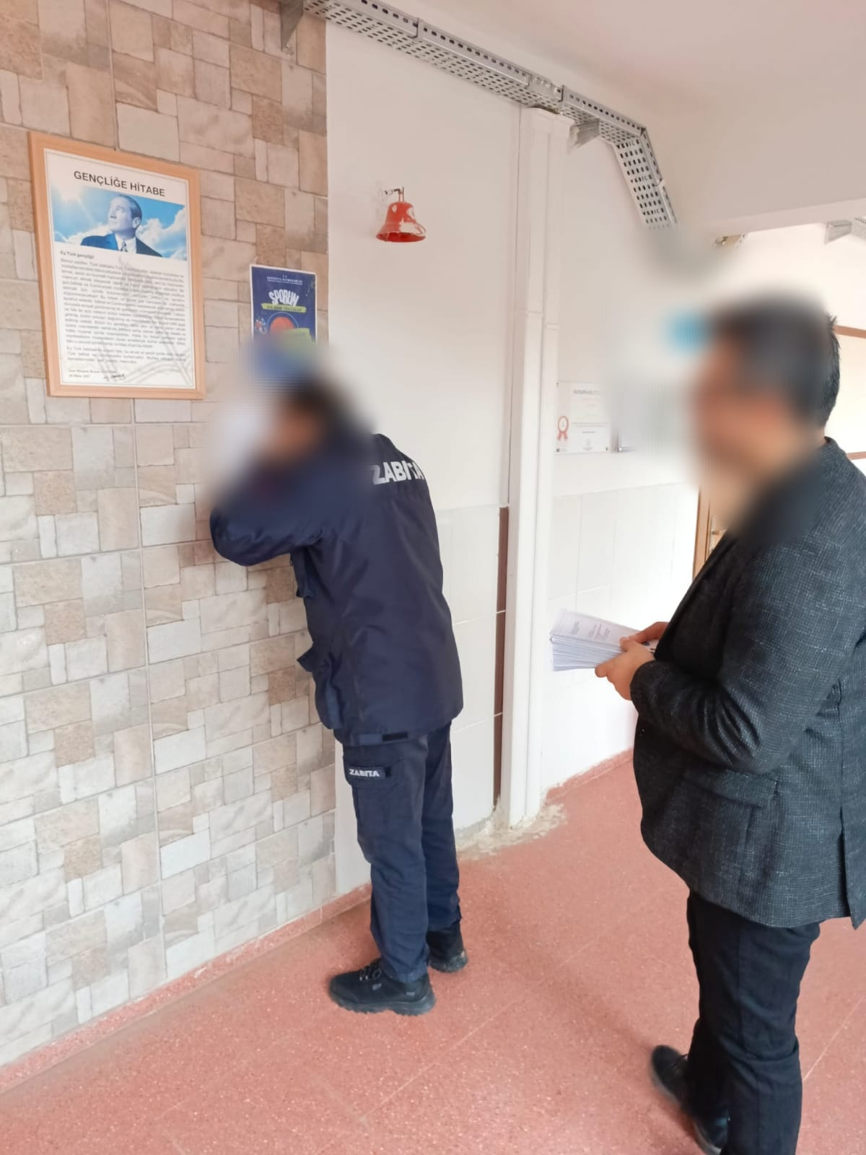

Distribution of Informational Brochures to Local Communities
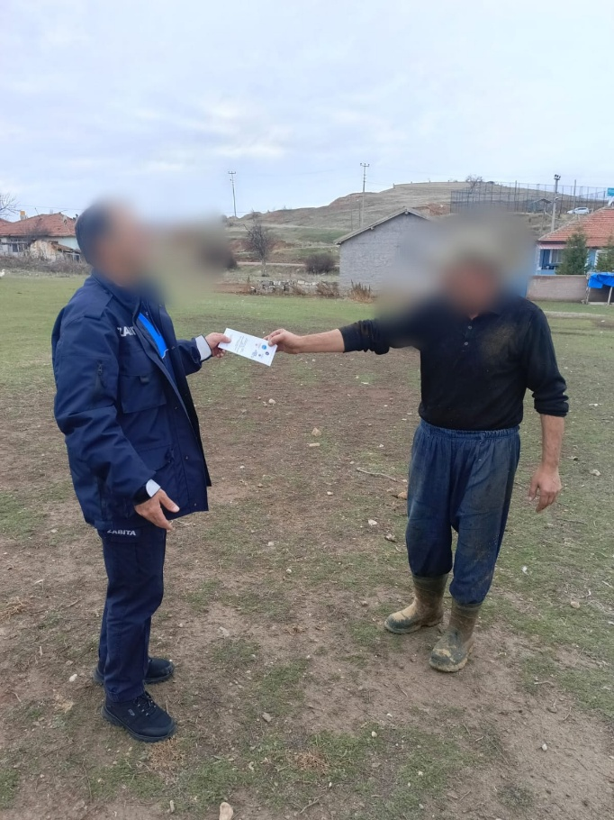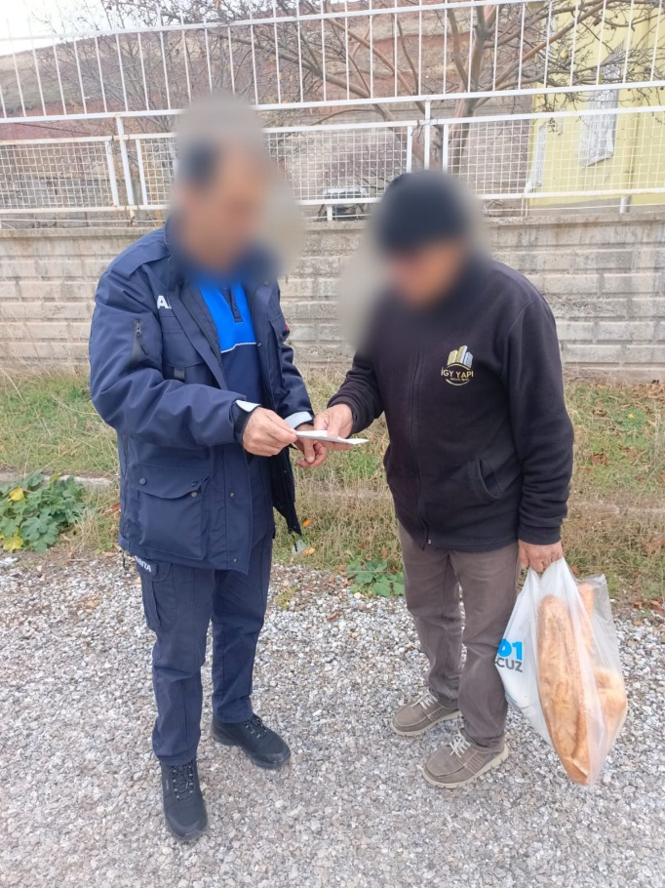
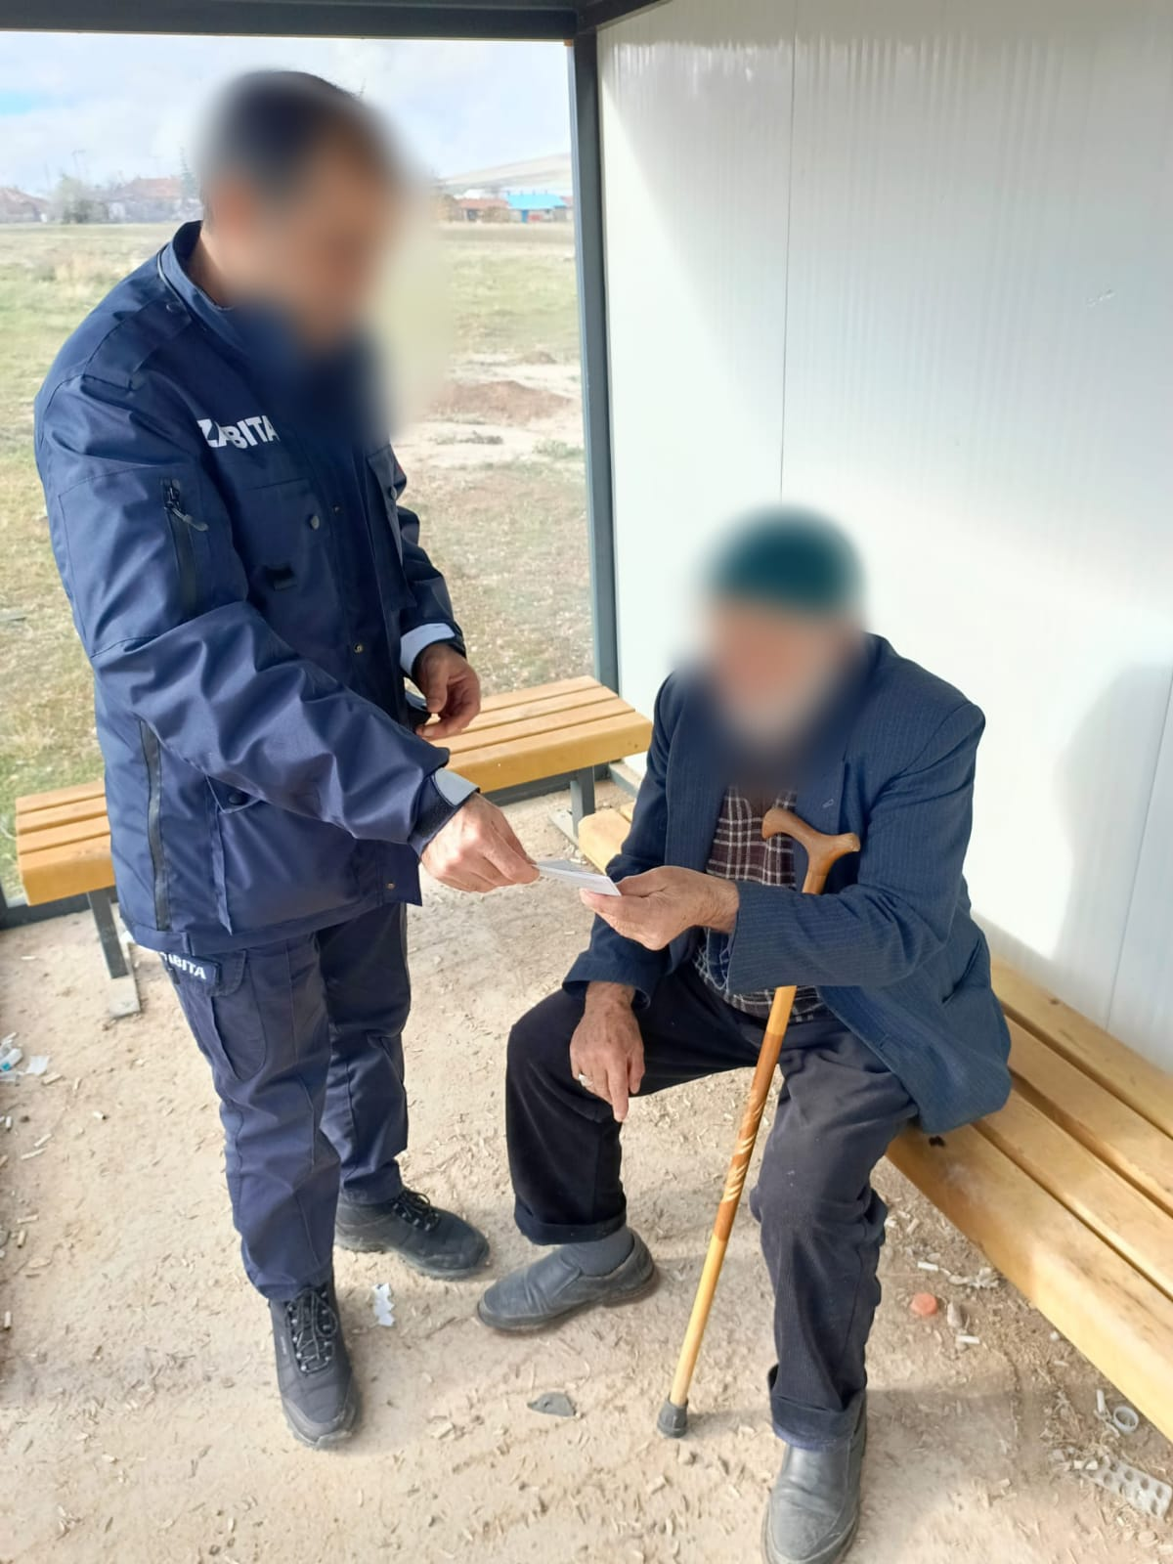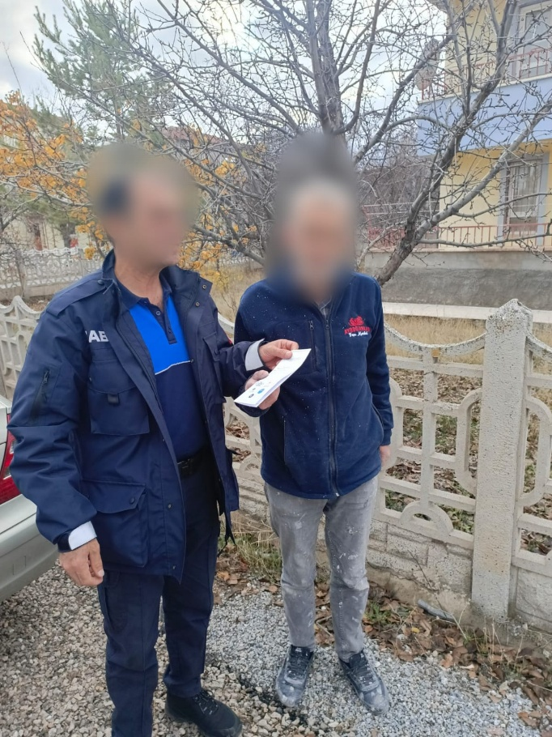
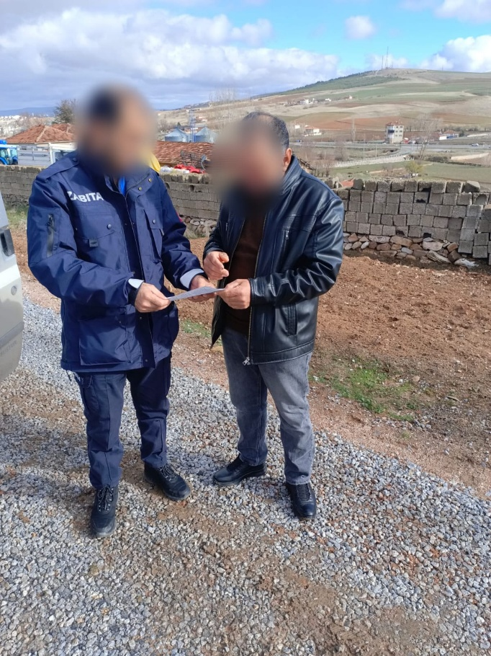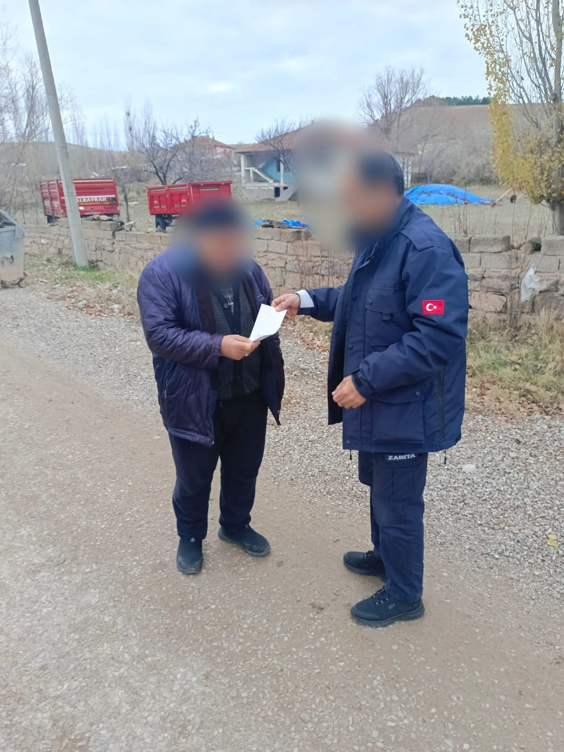
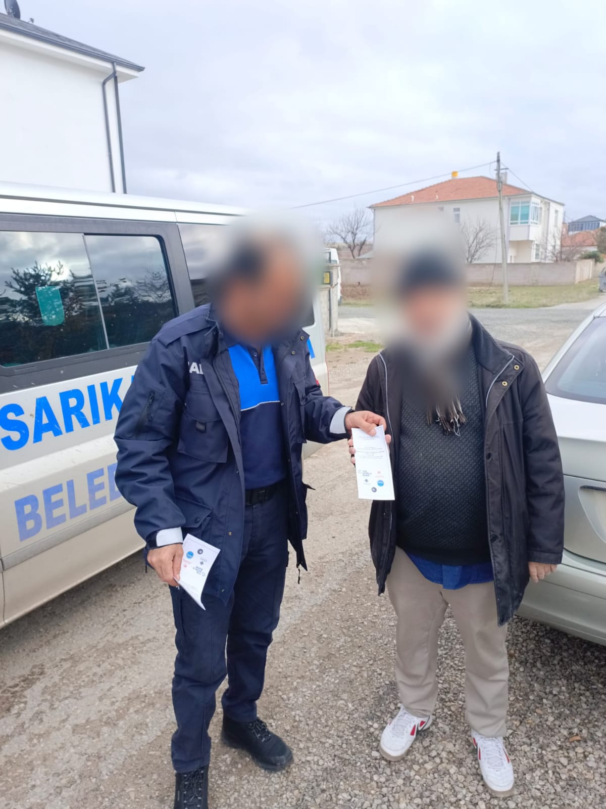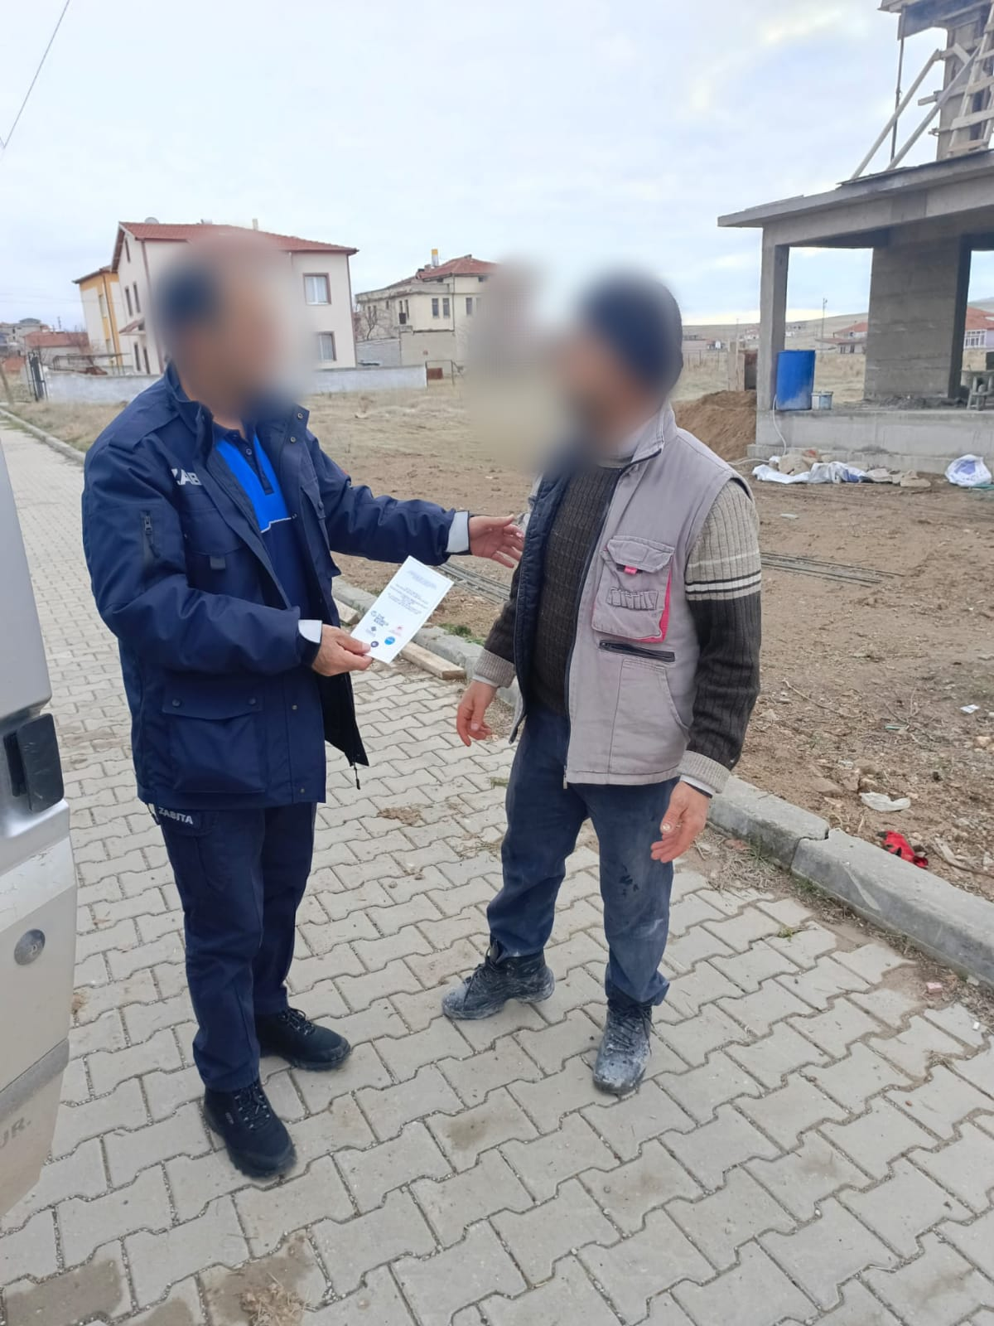
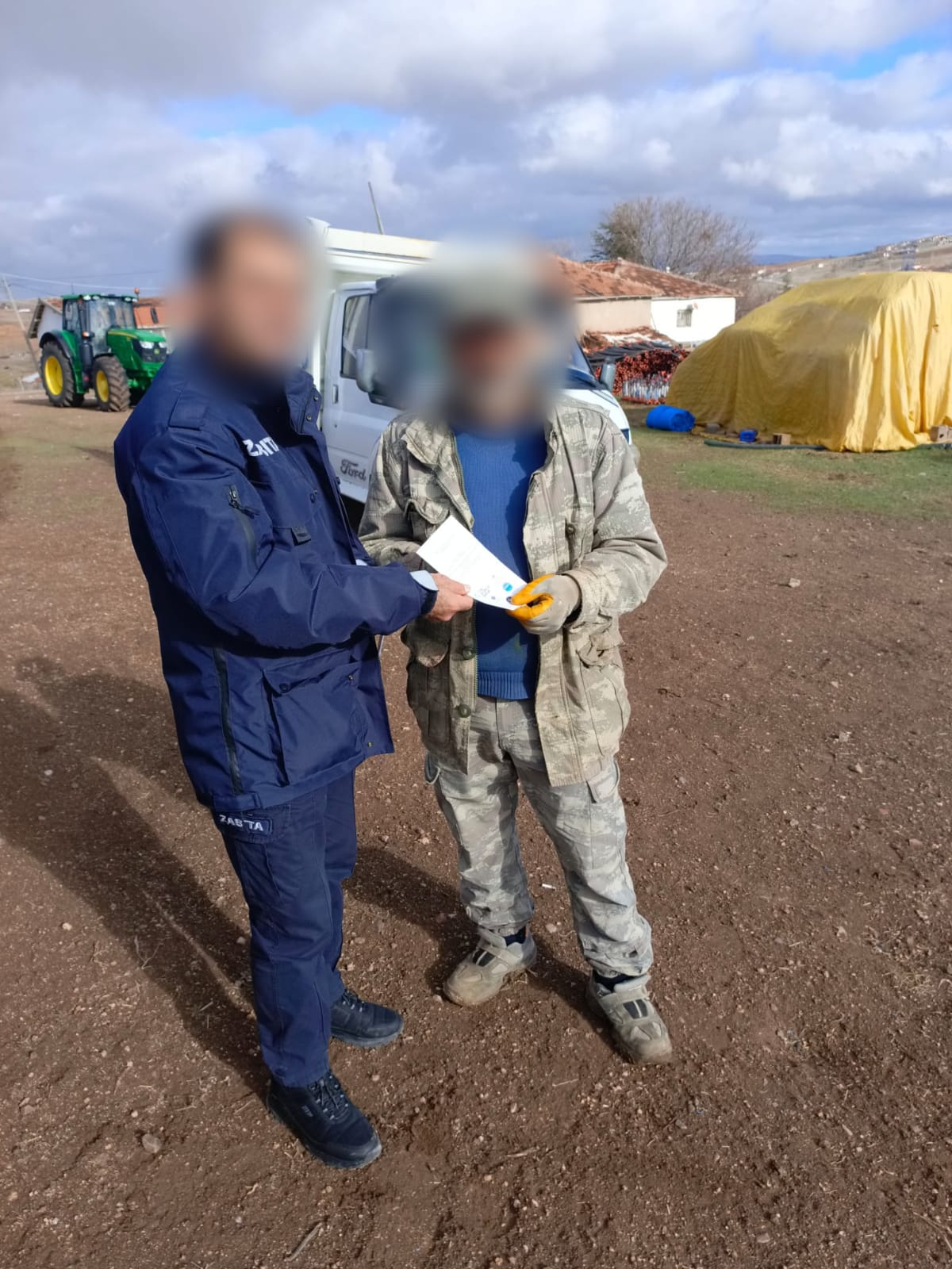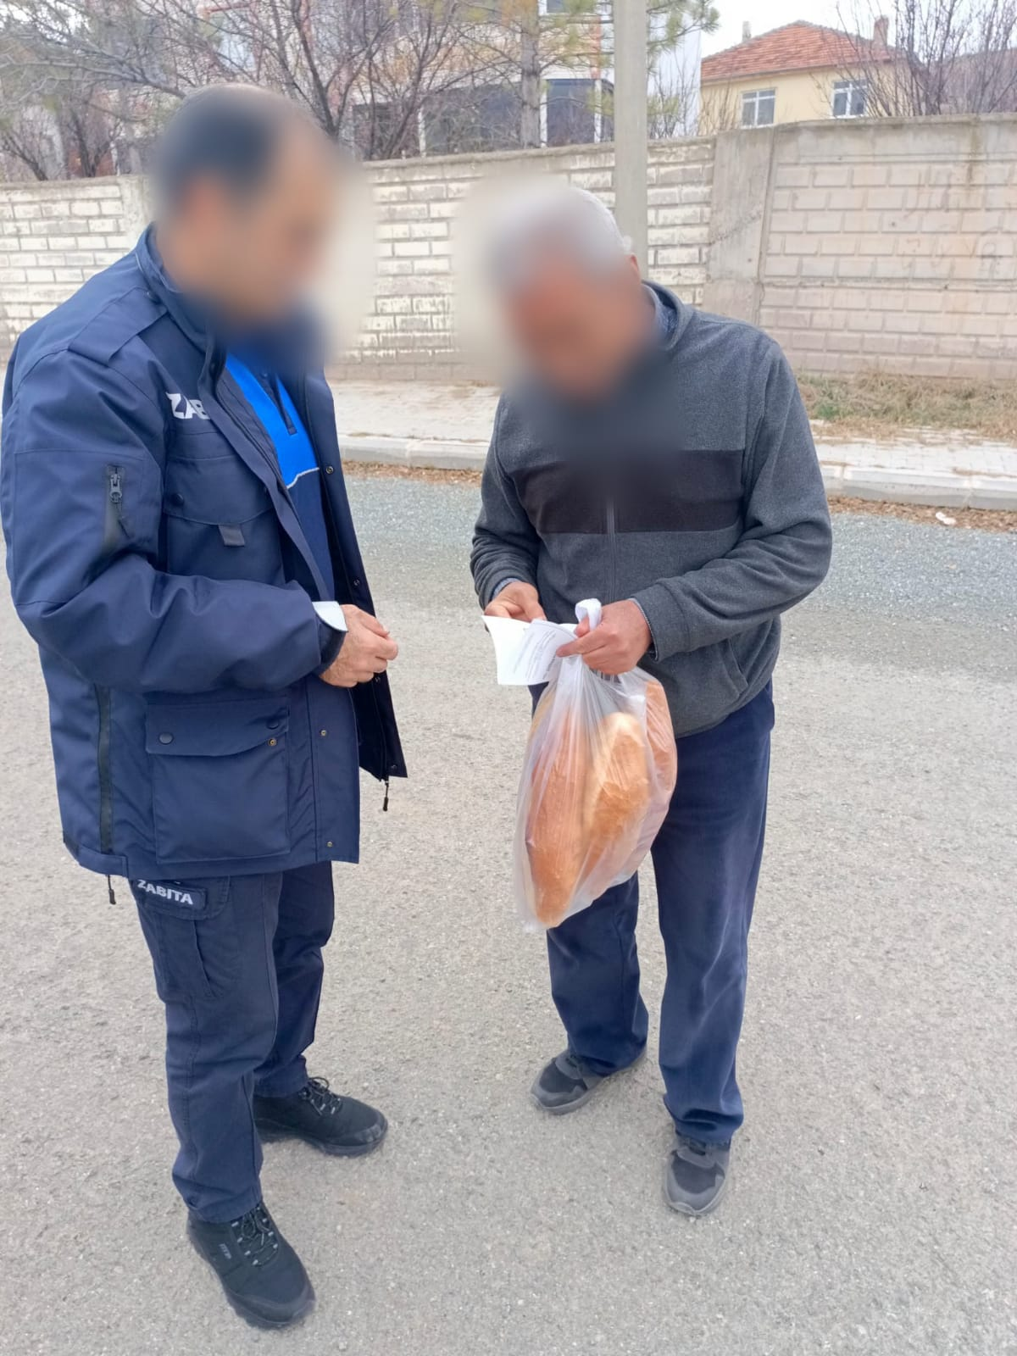

Annex-6: Brochure for the Sarıkaya Municipality Solar Power Plant Project Stakeholder Consultation Meeting
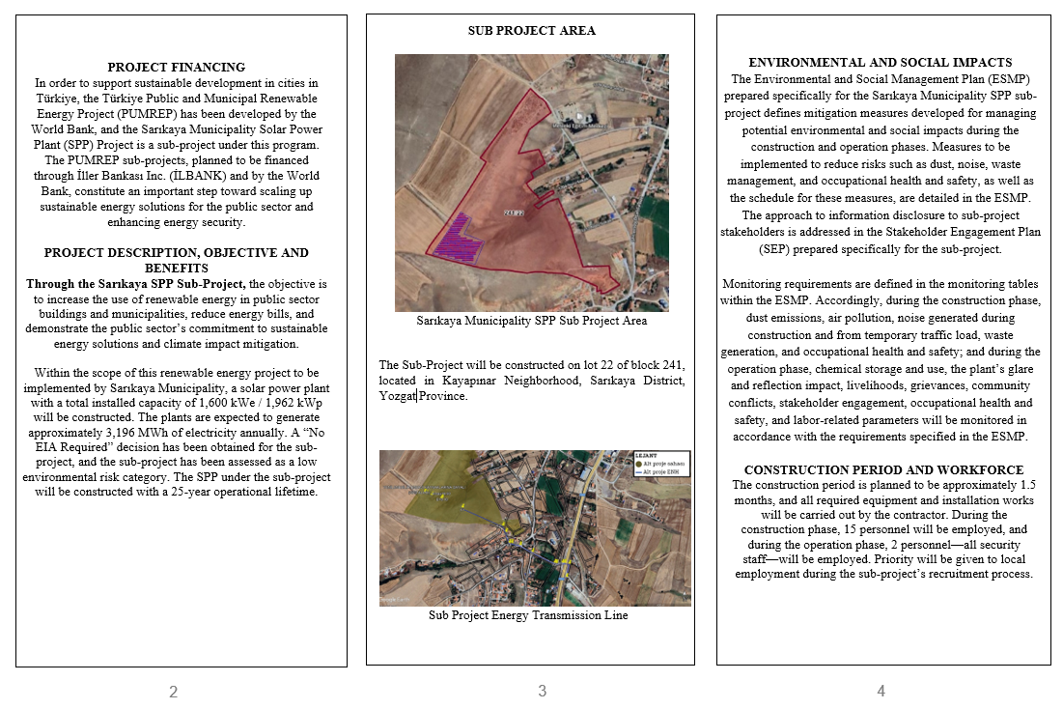
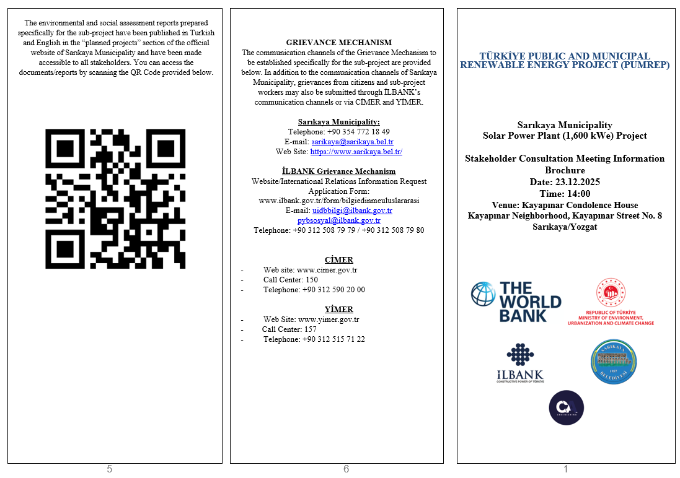

Annex-7: Presentation Delivered at the Stakeholder Consultation Meeting for the Sarıkaya Municipality Solar Power Plant Project
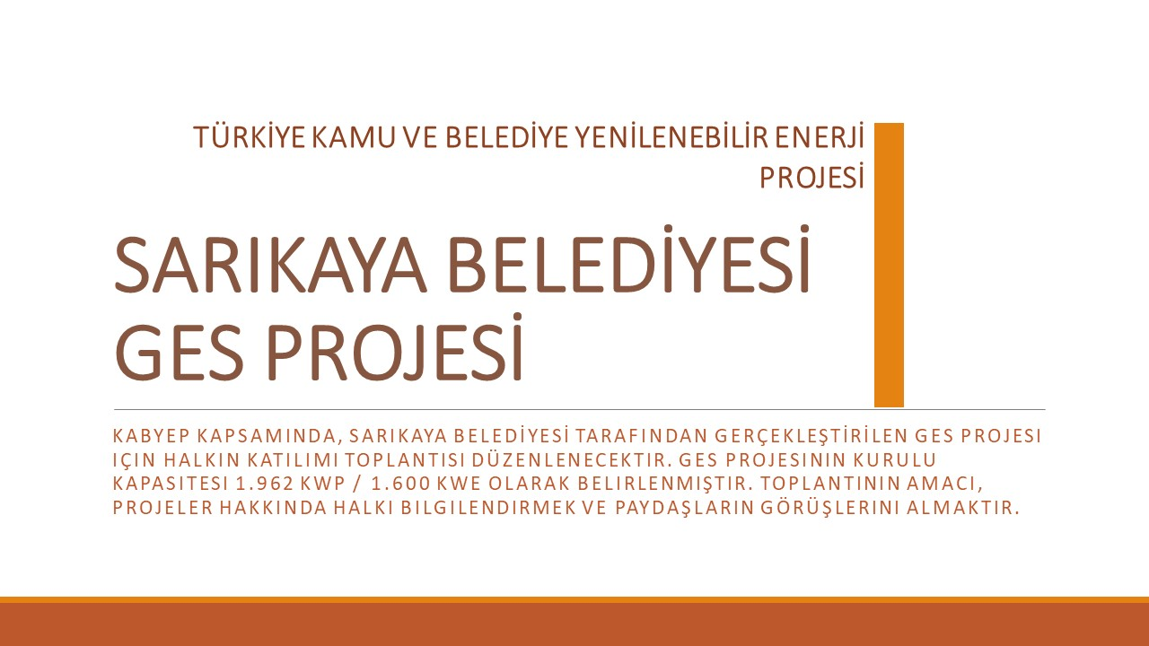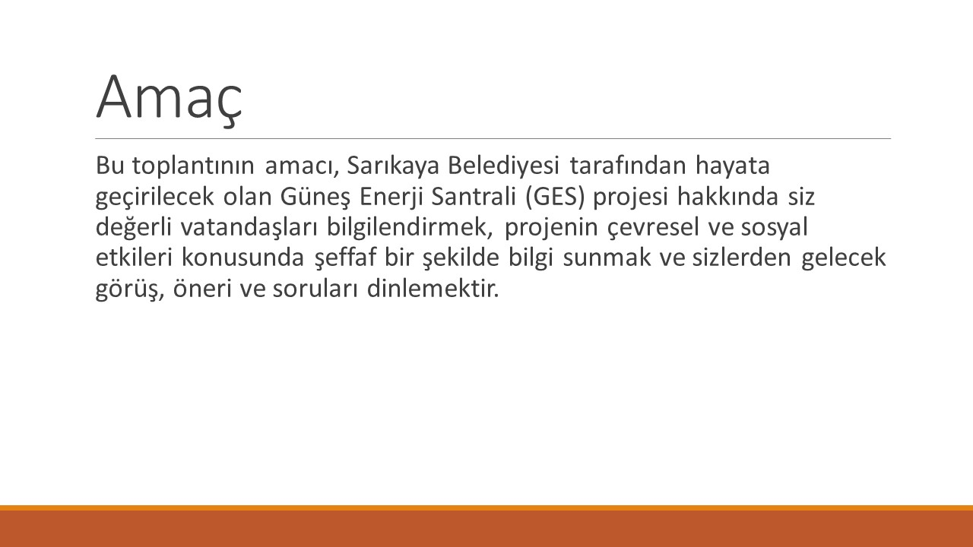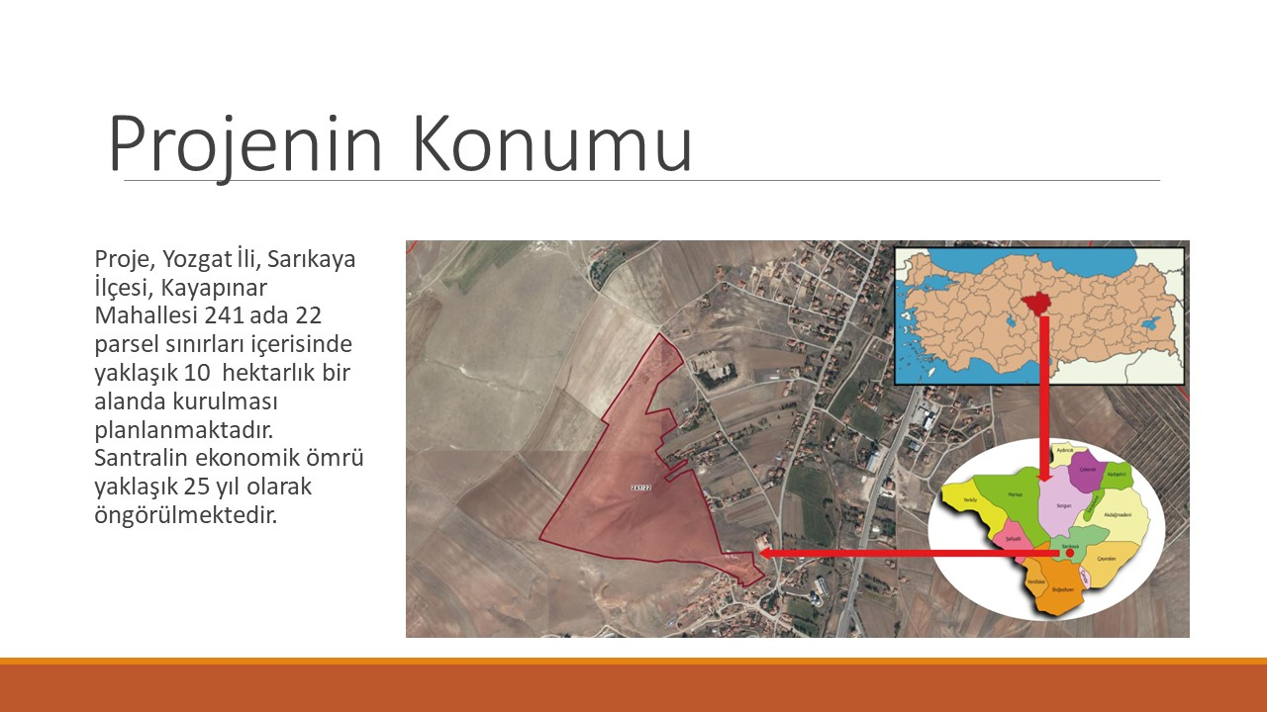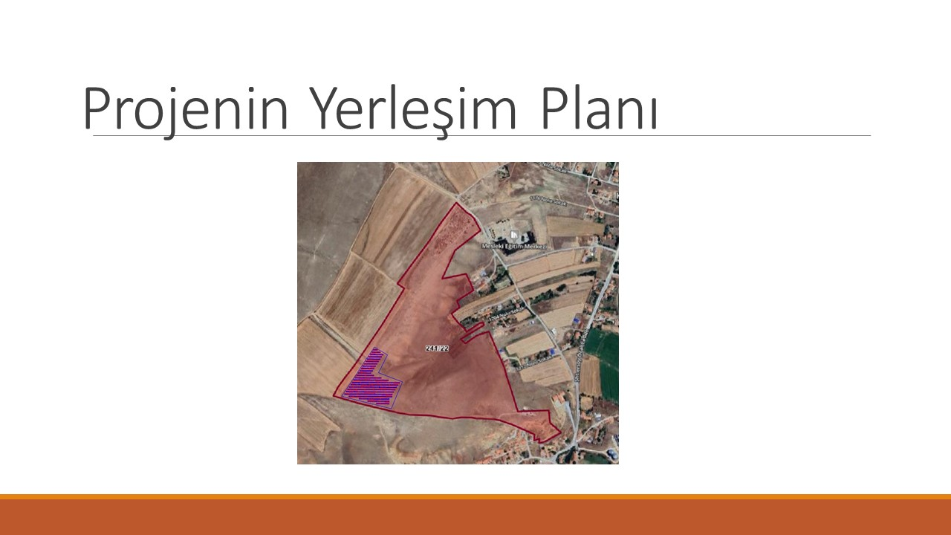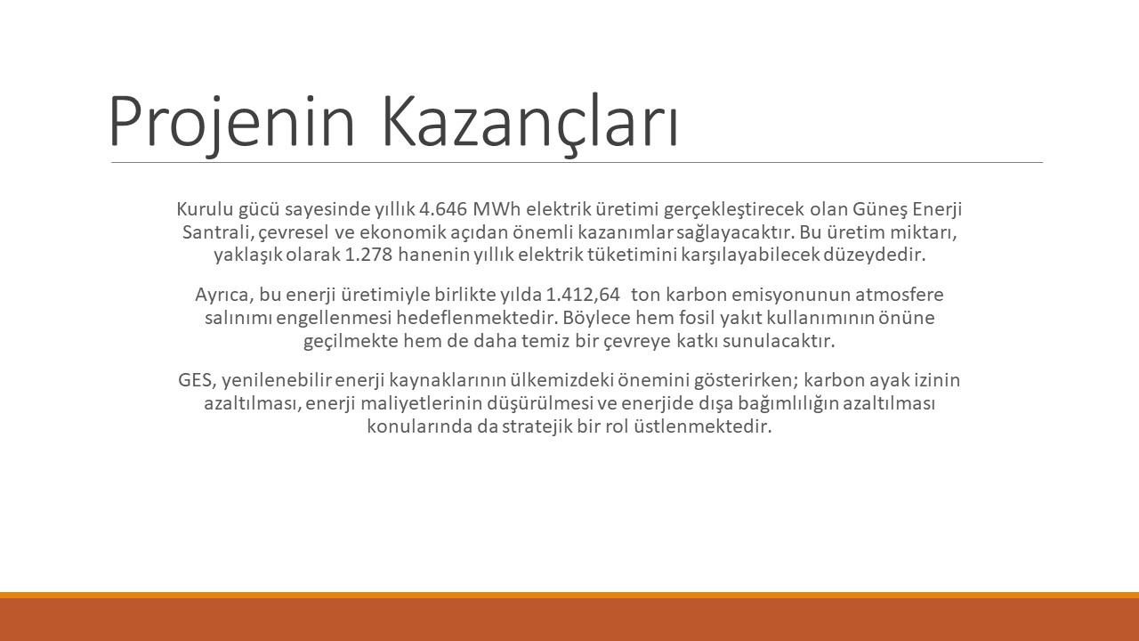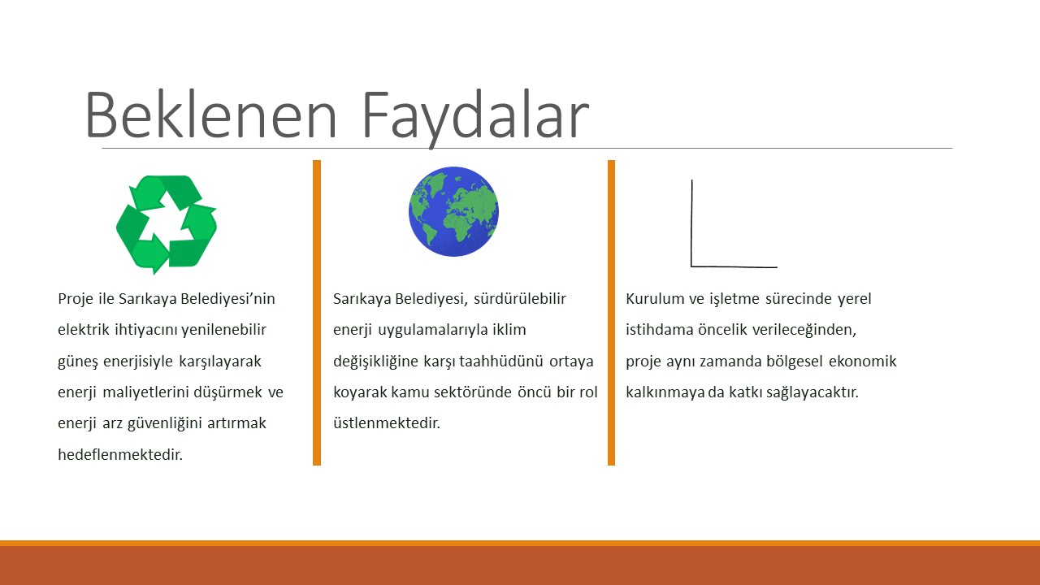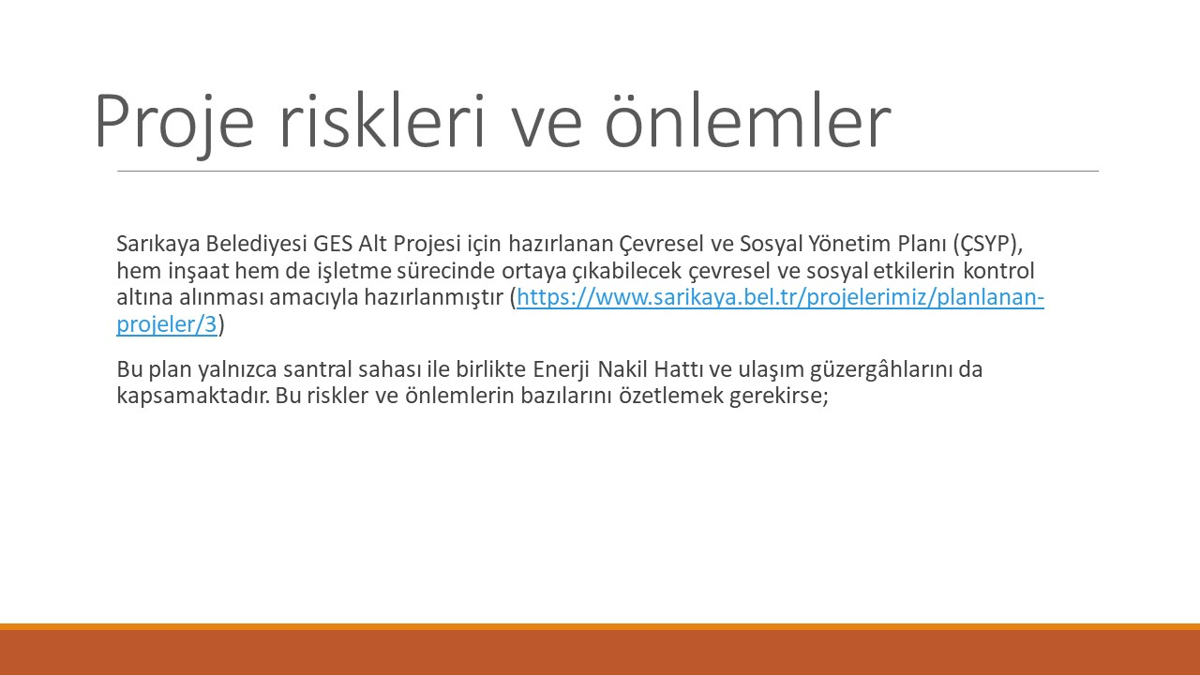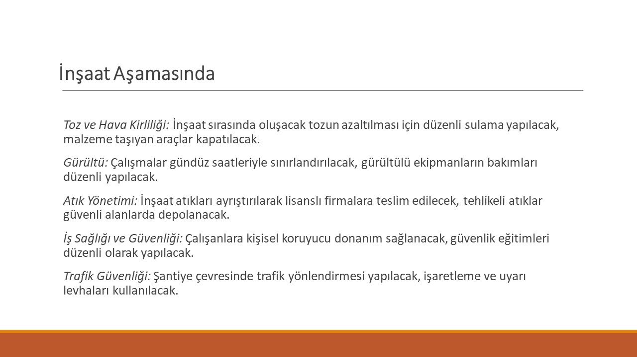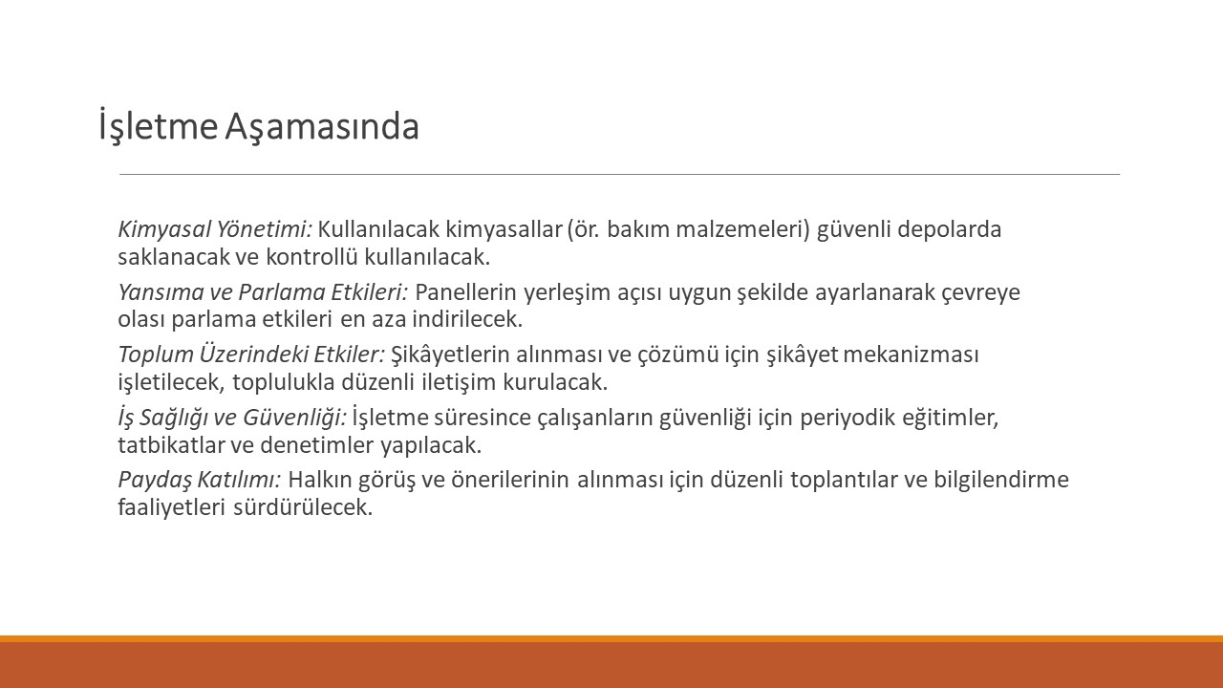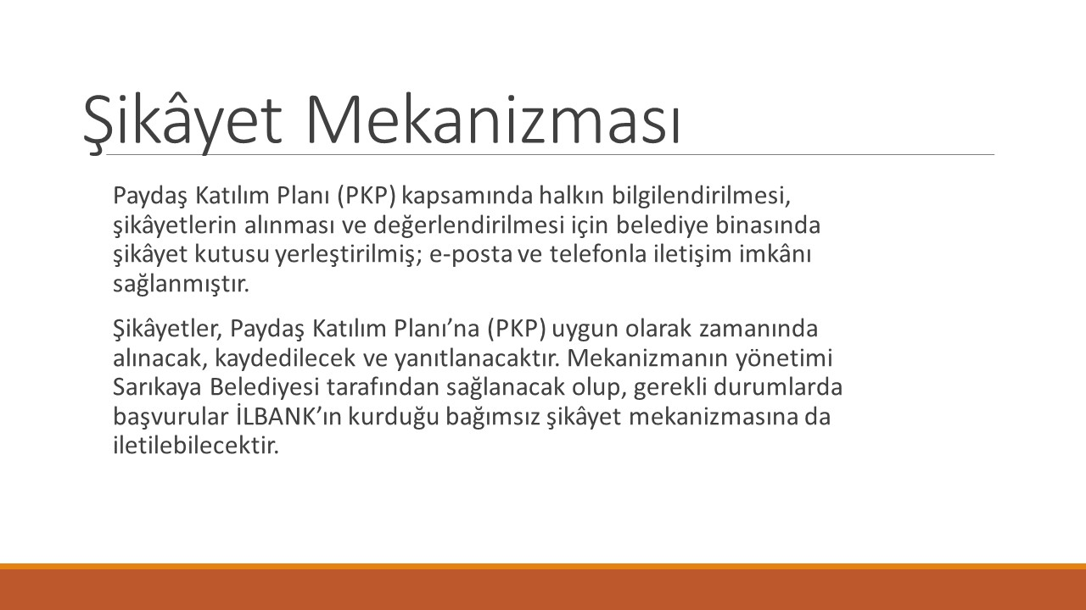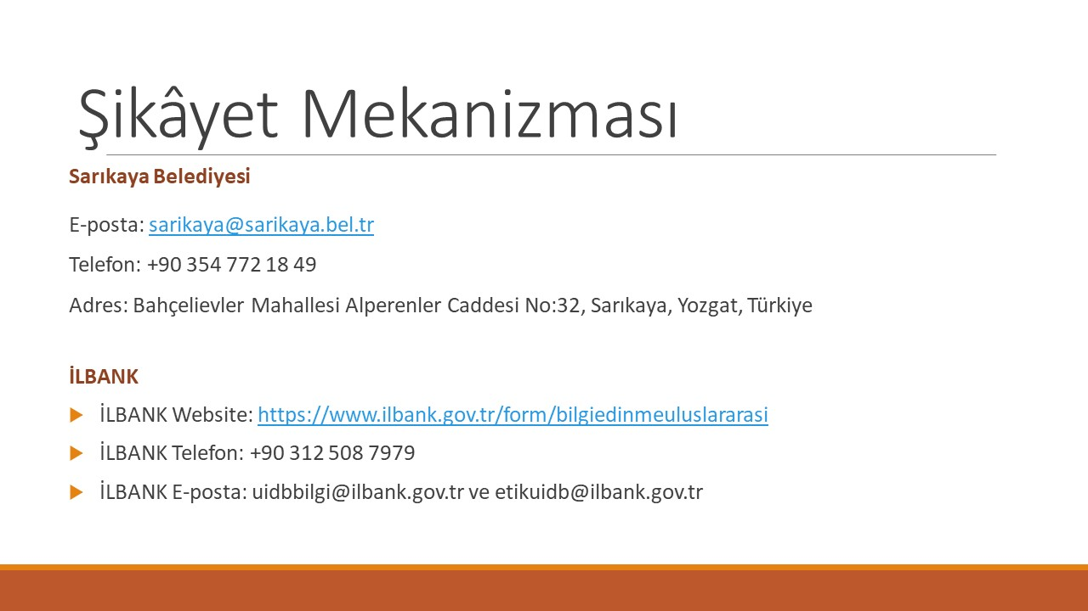
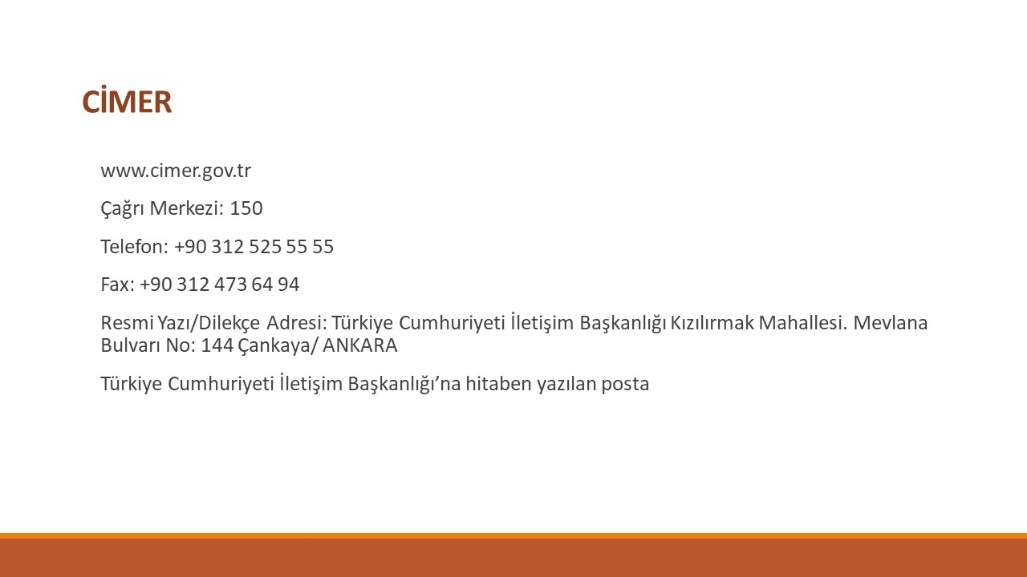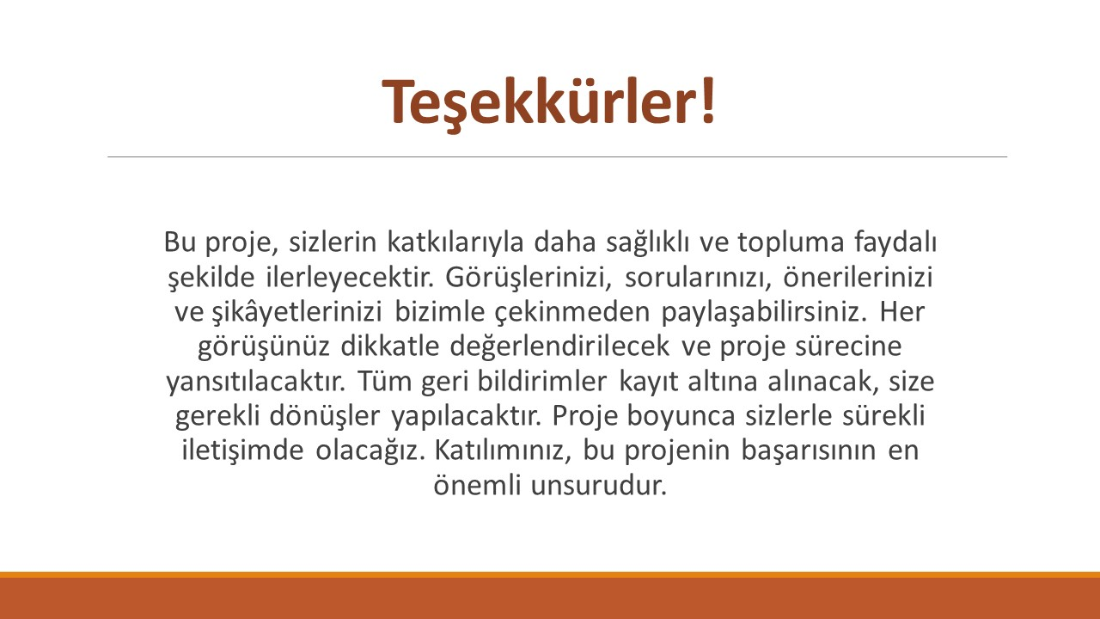

For details please see: https://www.ilbank.gov.tr/userfiles/files/Grievance_Mechanism.pdf

